**DESIGN AND IMPLEMENTATION OF A COMPUTERIZED CHILD ABUSE DATABASE MANAGEMENT SYSTEM**

**ABSTRACT**

The computerized child abuse database management system is a project proposed to create awareness among masses on the issues related to child abuse. The computerized system will keep tracks of all the suspicious incidents of child abuse by generating reports, aid law enforcement agency based on numerous details. Implementing this computerized system will play a crucial role in child welfare. The management system and data collection tools will meet with the Federal reporting requirements, it will also serve the information needs of an organizations, help inform management decisions and support caseworkers' interactions with children, youth, and families.

**CHAPTER ONE**

**INTRODUCTION**

**1.1 BACKGROUND OF THE STUDY**

The increased Violence against young people includes all types of violence, these occurs for ages between 0-18 years old. This violence may be child maltreatment (i.e. sexual and emotional abuse, neglect or physical violence) mostly between parents or other authority figures. Both genders (boys or girls) are at same risk of physical assault and emotional neglect and abuse, the females are at greater risk of sexual abuse or violence, this mostly leads to unwanted pregnancy or sexually transmitted diseases. As young people between this age groups reaches adolescence, peer violence and intimate partner violence, in addition to child maltreatment, becomes highly unavoidable. Violence against children can be avoided by setting up preventable measures. Preventing and addressing to violence against children requires that efforts the society, health workers and other organizations to systematically address the risk and protective factors at all four interrelated levels of risk (individual, relationship, community, society). World Health Assembly (May 2016), reached a resolution which endorsed the first ever WHO Global plan of action on tightening the roles of the health system within a national multisectoral response to fight against child neglect, interpersonal violence in particular against girls and women, and against children.The Online child abuse database management system when implemented, will be an application developed to move beyond addressing the impact of child abuse by seeking out the root cause and identifying ways to prevent it. This is an application created to trace out the statistics based on the reports about child abuse and help reduce the rates of the crime. It will maintain a centralized database of all scheme related information. This computerized system verifies and generate reports of incidents about abusive parents, physical and sexual abuse. The Child abuse application will maintain vital information about child abuse laws, it will provide details about those children who are in risk. Encounter the challenges with proper documentations which include misplacement of vital information or cases, as a result of large volume of work handled, duplicated or efforts due to inconsistency in activities, and a lot of time spent in searching for files or reports when needed for processing.

**1.2 STATEMENT OF THE PROBLEM**

The existing system, which is a manual process requires modification and replacement to enhance it effectiveness, they exist a lot of challenges associated with the old and existing system. The existing system faces numerous challenges due to the manual procedure of recording and keeping track of child abuse victims, which may include:

1. A lot of paper work is required to keep vital information, which may lead to lost or damage.
2. Unauthorized users can easily have access to sensitive information.
3. Processing time is slow and lengthy, most times data is duplicated.
4. Keeping multiple folders of child abuse report manually takes a lot of time and resources and some of the information is unreliable and inaccurate.

**1.3 AIM AND OBJECTIVES OF THE STUDY**

The primary objective of the project is to comprehend the challenges of the current system and to recognize the essential requirements and discuss how the computerization of the system can help in eradicating the challenges of the manual based system, with the following objectives:

1. To design a functionally database system for child abuse offenders and victims.
2. To compute child abuse records for easy retrieval.
3. Deny access to unauthorized personnel.
4. Help in the fight against child abuse across the country.

**1.4 SCOPE OF THE STUDY**

This study is not limited to or within any agency, it is designed and developed for the prevention and protection against child Abuse and Neglect.

**1.5 SIGNIFICANCE OF THE STUDY**

Child abuse and child neglect are social challenges that influences countless underage individuals, and something must be done to change these problems. They is a need to design a computerized child abuse and neglect database management system to help combat this issue. With findings from the research, it will help law enforcement agency, organizations and other agencies to solve the issues and challenges associated with inability to keep precise records effectively and reduce loss of vital information or reported cases. Furthermore, reduce the rate of child abuse across the country. This study will also be beneficial to scholars who want to do additional research on the study.

**1.6 LIMITATION OF THE STUDY**

The computerized system will be able to compute children abused over recent years, store complainant and offenders’ records for easy retrieval, since is the system is a web-based application, it will require internet access to be enable to access information on the platform.

**1.7 DEFINITION OF TERMS**

1. **Child:**Child is defined as the dependent person in the custody of a parent or guardian for protection of his/her life.
2. **Abuse:**It is any deliberate act by a person, group of person in the society designed to inflict on a child mentally, physically sexually or emotionally.
3. **Neglect:** This usually occur when families fail to or on their own part fail to provide the necessary need for their children such as food, medical care, being deprived of essential need of life.
4. **Violence:** Behavior involving physical force intended to hurt, damage, or kill someone or something.
5. **WHO**: World Health Organization.
6. **Online**: while connected to a computer or under computer control.
7. **Child Abuse:**This is a child this is physically, sexually, emotionally or psychologically maltreated by the parent, caregivers, teachers or group of persons.
8. **Offender:** This is a person who commits an illegal act. He/she is a criminal and guilty of an offence.
9. **Complainant:**A complainant is a person who lodges a complaint. It is a term used in content of criminal law to refer to person who alleges that another person committed a criminal act against him/her in a legal way. It is a person who reports a case or crime.

**CHAPTER TWO**

**LITERATURE REVIEW**

**Concept of Child Abuse and Neglect**

Child abuse can be defined as causing or permitting any harmful or offensive contact on a Childs body; and any communication or transaction of any kind, which humiliates, shames, or frightens the child. Some child development experts go a bit further, and define child abuse as any act or omission, .which fails to nurture or in the upbringing of the children (Brown and Salzinger, 2010).

Brown and Salzinger, 2010) also defined child abuse and neglect as: "at minimum, any recent act or fare to act on the part of a parent or caretaker which results in death serious physical ' emotional harm, sexual abuse or exploitation, or an act or failure to act which presents an imminent risk or serious harm". In addition the oxford-advanced learner's dictionary of contemporary English defines it as the crime of harming a child in a physical, sexual or emotional away.

It should be noted that any child of any sex, race, religion and socioeconomic background could fall victim to child abuse and neglect (Chaffin, 2011).

**Types of Child Abuse and Neglect**

Child abuse and neglect consists of any acts of commission or omission by a parent or other caregiver that results in harm, potential for harm, or the threat of harm to a child (0–18 years of age) even if the harm is unintentional (Gilbert et al., 2009). The five main types of child maltreatment are: physical abuse, sexual abuse, emotional maltreatment, neglect, and witnessing domestic violence.

Evidence suggests that different types of abuse and neglect rarely occur in isolation and children who experience repeated maltreatment often experience multiple forms of abuse (Cancian and Caspar, 2008).

**EMOTIONAL ABUSE:** it is also seen as verbal a use mental abuse, and psychosocial maltreatment. It includes acts or the failure to act by parents or caretakers that have consent or could cause, serious behavioral, cognitive emotional, or mental disorders. '

This can include parents/caretakers using extreme end/oy boxcar forms of punishments, such as confinement in a closet or dork room or being tied to a chair for long periods - of time or threatening or terrorizing a child less severe acts, acts, but no less damaging ore belittling or rejecting treatment, using derogatory terms to describe the child, habitual scapegoat or blaming (Corso and Mercy, 2008).

**SEXUAL ABUSE:** the inappropriate sexual behavior with a child. It includes fondling a child's genitals, making the child fondle the adult's genitals, intercourse, incest, rape, soloing, exhibitionism and sexual exploitation. To consider, child abuse, these acts have to be committed by a person responsible for the care of a child (e.g. a baby-sitter, a parent, or a daycare provider) or related to the child. It a stranger commits these acts it would be conditioned sexual assault and handled solely by the police and criminal courts (Gilbert and Janson, 2009).

**NEGLECT**: the failure to provide for the child's basic needs neglect can be physical, educational, or emotional. Physical neglect can include not providing adequate food or clothing appropriate medical core, supervision, or proper weather .protection (haut or cots). It may include abandonment. Educational neglect includes. Failure to provide appropriate scooting or special educational needs, allowing excessive truancies. Psychological neglect includes the lack of any emotional support and love, never attending to the child, spousal abuse, clung and alcohol abuse including allowing the child to participate in drug and alcohol use physical abuse: the inflicting of physical inpruy upon a child (Gillham, 2010). This may include, brining, hitting, punching, shaking, kicking, beating, or otherwise harming a child. The parent or caretaker may not have intended to hurry the child; the injury is not an accident. It may, however, been the result of over-discipline or physical punishment that is inappropriate to the child's age (Gornick and Meyers, 2015).

**Incidences of Child Abuse and Neglect**

i) Child trafficking

'ii) Hawking on the street.

iii) Begging in the street

iv) Children living under the bridge

v) Children deprived of standard education

vi) Exposing children to sexual harassments

vii) Preventing child from proper medication

viii) Child abduction

These and many more are incidences of child abuse in Nigeria

**Factors affecting the contributing to Child Abuse and Neglect**

Children and young people are affected by abuse and neglect in various ways. Outcomes of abuse may range from mild symptoms to debilitating and life-threatening conditions (Jones and McCurdy, 2012). Factors that may affect the way in which abuse and neglect affects children and adolescents include:

􀂄 the age and developmental status of the child when abuse occurred;

􀂄 the severity of maltreatment;

􀂄 the frequency and duration of maltreatment;

􀂄 the relationship between the child and the perpetrator; and

􀂄 the type(s) of abuse/neglect.

So many factors have in one-way cloth other brought about or increased the rate of child abuse Nigeria. These causes may be as a result of certain activities and parental actions which has gone beyond control and has effected the Nigerian child some of this factor include: -

**POVERTY:** this factor has been seen to be one of the major causes of child abuse in Nigeria. Its responsible for the increasing number of street kids in the major Nigerian critics, - wherever there is a highly level of poverty take for instance in

Nigeria today, naturally you see people resorting to begging on the streets for a living because there is loss of jobs, dignity and the resulting effect will gradually shift to street begging (Jones, 2010).

The poor standard of education of children is a result of poverty considering the fact that Nigeria The poor standard of education of children is a result of poverty considering the fact that Nigeria schools happens to be very 'expensive that only the rich can-afford it, leaving the poor masses with no-other option that to enroll in low standard schools, stay at home or go out in the street begging for arms to aid themselves. Poverty has made so many children resort to the sleeping under the bridge due to high cost of living and rent which the poor cannot afford as such at this present state the child is prone to summary hazard that might be detrimental to his/her health and might eventually in one way or the other led to death.

**DIVORCE:** divorce is actually one thing that has also brought child abuse to its climax; it also has destroyed marriages etc.

In a situation where by a family/home is broken as a result of divorce, the children in such a home are left to themselves. To do whatever they which to do. At this point in time certain group influence that a detrimental to their behavioral way of life and otherwise.

**LACK OF ATTENTION:** anyone left to himself is prone to many things, parental love, care and attention truly matters in child upbringing. Lack of attention from parents to the children leaving them to house helps who tend to inculcate various ways of behavior into the children, this impacts actually makes them. Imagine a situation where 'both father and mother leaves home in the morning and is set to come back by midnight house, in this case the children set eye on their parents only on weekends not knowing what and what has transpired in their absence.

Until parents began to devote most of their time to the upbringing of their children, child abuse will have an upper- hand in the society at large.

**DEATH:** So many orphans have been exposed to child abuse at a very high rate considering the fact that they do not have parents *any* longer who take care of them or look after them.

Orphans who are left to their uncles and relatives after

**A** - the death of their parents tend to suffer child abuse due to some level of hatred and wickedness from their aunts/ uncles. This wicked uncles might send this orphans to go hawking which exposes them to risk of death by accident, sexual harassment, rape and kidnap etc. and also poor feeding, maltreating them and sometimes they are not sent to school.

**SOCIETAL INFLUENCE:** This is seen from an ideology that indulging in under aged sex refreshes the blood.

Following the context, so many men of high age grade tend to sleep or rather make love to maidens as old as their daughters all in the name of a quest for fresh blood which I don't think is obtainable in such an act but is an abuse to the teenager involved in such a mess. It is no longer news to hear that a father impregnates his own daughter causing her unnecessary pains which are not worth it.

**Consequences of Child Abuse and Neglect**

The consequences of maltreatment can be devastating. For over 30 years, clinicians have described the effects of child abuse and neglect on the physical, psychological, cognitive, and behavioral development of children. Physical consequences range from minor injuries to severe brain damage and even death. Psychological consequences range from chronic low self-esteem to severe dissociative states. The cognitive effects of abuse range from attentional problems and learning disorders to severe organic brain syndromes. Behaviorally, the consequences of abuse range from poor peer relations all the way to extraordinarily violent behaviors. Thus, the consequences of abuse and neglect affect the victims themselves and the society in which they live.

Many complexities challenge our understanding of factors and relationships that exacerbate or mitigate the consequences of abusive experiences. The majority of children who are abused do not show signs of extreme disturbance. Research has suggested a relationship between child maltreatment and a variety of short- and long-term consequences, but considerable uncertainty and debate remain about the effects of child victimization on children, adolescents, and adults. The relationship between the causes and consequences of child maltreatment is particularly problematic, since some factors (such as low intelligence in the child) may help stimulate abusive behavior by the parent or caretaker, but low intelligence can also be a consequence of abusive experiences in early childhood.

**Medical and Physiological Consequences**

Physical abuse in infants and young children can lead to brain dysfunction (Dykes, 2010) and sometimes death. Most fatality victims of abuse and neglect are under age 5. In 1991, an estimated 1,383 children died from abuse or neglect; 64 percent of these deaths were attributed to abuse and 36 percent to neglect. However, the number of child deaths caused by abuse and neglect may actually be much higher, since cause of death is often misclassified in child fatality reports.

A child does not need to be struck on the head to sustain brain injuries. Dykes (2010) has indicated that infants who are shaken vigorously by the extremities or shoulders may sustain intracranial and intraocular bleeding with no sign of external head trauma. Thus early neglectful and physically abusive practices have devastating consequences for their small victims.

Neglect cases may occur at any point of a child's development but are often associated with early childhood, when they are more likely to be discovered by health professionals, educators, and child welfare workers. One form of child neglect is associated with *nonorganic failure to thrive* infants. The absence of physical growth in these infants can be measured by objective scales of weight and height (Drotar, 2012). Neglect is usually suspected when such infants demonstrate significant weight gain following hospital admission or child removal from the family. Deprivational dwarfism, a medical term applied to children of small stature whose physical growth is impaired by the absence of nutritional requirements, is another type of child neglect associated with some young children. Even after diagnosis and treatment, the psychological consequences of emotional neglect persist. Drotar (2012) notes that factors that trigger nonorganic failure to thrive and child neglect should be separated from factors that maintain these behaviors. In early periods of neglectful behavior, the child may exhibit stressful behaviors in the forms of feeding problems, irritability, or deficits in social responsiveness that place increased demands on the parent's caretaking duties. In some cases, nutritional deprivation, combined with increased maternal detachment, sets into motion a "vicious cycle of cumulative psychological risk" (Drotar, 2012). Eventually, the parent may begin to perceive the child as quiet, sickly, or not very competent, perceptions that may not be shared by others who observe the child. In the absence of growth indicators of nonorganic failure to thrive or deprivational dwarfism, clinical diagnosis of child neglect is quite difficult.

Abuse and neglect may result in serious health problems that can adversely affect children's development and result in irremediable lasting consequences. Early studies of physically abused children documented significant neuromotor handicaps, including central nervous system damage, physical defects, growth and mental retardation, and serious speech problems (Aber and Cicchetti, 2014). Physically abused children have been found to have more mild neurologic signs, serious physical injuries, and skin markings and scars than their nonabused peers. Children who have been sexually abused, and some children who have been physically neglected, have shown heightened sexuality and signs of genital manipulation. A particularly serious biological consequence of child and adolescent sexual abuse is the risk of sexually transmitted diseases, including human immunodeficiency virus, gonorrhea, and syphilis.

**Cognitive and Intellectual Consequences**

Cognitive and language deficits in abused children have been noted clinically (Abram, 2010). Abused and neglected children with no evidence of neurological impairment have also shown delayed intellectual development, particularly in the area of verbal intelligence. Some studies have found lowered intellectual functioning and reduced cognitive functioning in abused children . However, others have not found differences in intellectual and cognitive functioning, language skills, or verbal ability.

Problematic school performance (e.g., low grades, poor standardized test scores, and frequent retention in grade) is a fairly consistent finding in studies of physically abused and neglected children, with neglected children appearing the most adversely affected. The findings for sexually abused children are inconsistent.

Alessandri (2011) found that physically harmed 4-year-old children showed deviant patterns of processing social information, related to aggressive behavior, at age 5. Physically harmed children (relative to non physically harmed children) were significantly less attentive to social cues, more inclined to attribute hostile intent, and less able to manage personal problems. They explain possible cognitive deficits in abused and neglected children by suggesting that physical abuse affects the development of social-information-processing patterns, which in turn lead to chronic aggressive behavior. The experience of severe physical harm is associated with the "acquisition of a set of biased and deficient patterns of processing social provocation information".

Differences in findings on the cognitive and intellectual consequences of childhood maltreatment may be related to the failure to control for important variables, such as socioeconomic status, and the lack of statistical power of small sample sizes. Other possible explanations for the inconsistencies in this literature are the tendency of earlier studies to aggregate different types of maltreatment (which may mask different consequences associated with specific forms of child maltreatment) or the inclusion of children who had neurological dysfunction to begin with (which can dramatically influence cognitive and intellectual performance). More recent studies have excluded children with obvious neurological impairments. Yet maltreatment, especially early maltreatment, can cause injury to the central nervous system that results in future cognitive impairments (Alfaro, 2011).

**Psychosocial Consequences**

Some studies suggest that certain signs of severe neglect (such as when a child experiences dehydration, diarrhea, or malnutrition without receiving appropriate care) may lead to developmental delays, attention deficits, poorer social skills, and less emotional stability. Consequences of physical child abuse have included deficiencies in the development of stable attachments to an adult caretaker in infants and very young children. Poorly attached children are at risk for diminished self-esteem and thus view themselves more negatively than nonmaltreated children. In several studies, school-age victims of physical abuse showed lower self-esteem on self-report and parent-report measures (Kaufman and Cicchetti, 1989), but other studies found no differences ( Stovall, 2010).

The consequences of neglectful behavior can be especially severe and powerful in early stages of child development. Drotar (2012) notes that maternal detachment and lack of availability may harm the development of bonding and attachment between a child and parent, affecting the neglected child's expectations of adult availability, affect, problem solving, social relationships, and the ability to cope with new or stressful situations.

Nearly all the children in this study whose mothers were psychologically unavailable were anxiously attached at 18 months of age, with the majority of these classified as anxious avoidant (86 percent). These children were observed with their mothers in a problem-solving situation at 24 months and a teaching task at 42 months and were found to be angry, non complacent, lacking in persistence, and displaying little positive affect. One of the most dramatic findings for these children was the nearly 40 point decline in performance on the Bayley Scales of Infant Development between 9 and 24 months. In the preschool classroom, these children presented varied and serious behavior problems.

Linkages between parental behaviors that have emotionally or psychologically destructive consequences on children have not been clearly established. While verbally or symbolically abusive acts designed to terrorize or intimidate a child (such as constant belittling or the destruction of a favorite object or pet) are associated with severe long-term consequences (Vissing, 2012), the processes by which children interpret aggressive or neglectful actions are poorly understood. The failure to provide age-appropriate care (such as parental availability and nurturance), cognitive stimulation, or achievement expectations also can have profound psychological impact, especially when such omissions occur during critical child and adolescent developmental periods.

Inappropriate sexual behavior, such as frequent and overt self-stimulation, inappropriate sexual overtures toward other children and adults, and play and fantasy with sexual content, are commonly cited as symptoms of sexual abuse in studies that compare sexually abused with non abused or nonclinical children. Across six studies of sexually abused preschoolers (those most likely to manifest such symptoms), approximately 35 percent of the abused children showed such behaviors. Sexual abuse has also sometimes been associated with the onset of sexual activity in middle childhood. Reported rates vary widely because of differences in samples, measurement instruments, and definitions of the outcome behavior. The lowest estimates (of 7 percent) were based on a large study that included many well-functioning and older children (Augoustinos, 2010). While sexualization seems relatively specific to sexual abuse, inappropriate sexual behavior has been noted in nonsexually abused children.

Sexually abused children, particularly those abused by a family member, may show high levels of dissociation, a process that produces a disturbance in the normally integrative functions of memory and identity (Ayoub and Milner, 2015). Many abused children are able to self-hypnotize themselves, space out, and dissociate themselves from abusive experiences. In some clinical studies, severely abused children appear to be impervious to pain, less empathetic than their nonabused peers, and less able than other children to put their own suffering into words (Jacobson, 2010).

**CHAPTER THREE**

**METHODOLOGY**

**3.0 System Study and Investigation**

The chapter involved a critical study of the existing management systems known as Child Abuse Management System. This chapter introduces the methodology and techniques that were used in acquiring and analyzing information and to achieve the objectives of the project. It therefore includes the methods, technique, design tools, approaches and procedures which were adopted to collect and analyze information. The methods that were used include interviews, document analysis, and observation.

**3.0.1 Interviews**

This method was used to collect information from Child Safety Monitoring Center administrators as the researcher was asking questions about the current system. Interviews were conducted with Dr. Maxwell John one of the Doctors of the Center and a Senior administrator, Mrs Agnes the midwife and Warden plus Mrs. Halimah the receptionist. During the interviews, these individuals described the process they involved and problems of abuse faced by the children and from the interviews with other staff members plus some expectant mothers, the researcher was able to identify the problems faced and the user requirements for the proposed system.

Reasons for using such a method;

* To obtain detailed information Personal perception opinions.
* To spell out ambiguities and a fall up of incomplete answers.

**3.0.2 Document Review**

With this method, the researcher reviewed market documents which included Records of children being abused, abuse record and case report. This method helped the researcher to obtain various information captured for different events and it was a supplement to the information from the interviews made at Child Safety Monitoring Center.

8

**3.0.3 Observation**

Observations were carried out accompanied by visits to the Child Safety Monitoring center where the research was carried out, participants and their daily conduct of activities, events and their sequence and attendant processes. In this line this kind of method helped the researcher to gain a clear flow of the activities involved and how they were conducted.

**3.1.0 Requirement Specifications**

Requirements specifications involve what the system should do. Therefore it provides detailed documentations of requirements and these are categorized into collection and analysis of user requirements, functional requirements and systems requirements.

**3.1.1 User Requirements**

In this line it comprised of the preferred features by the user in the system on which from the interviews and comments from the Child Safety Monitoring’s staff and users to be using the system it was revealed that the system should be able to;

* Provide user friendly interfaces for easy interactions.
* Allow users to enter data easily from the interface and is saved to the database.
* Print the necessary reports with the most accurate information.
* Restrict unauthorized login attempts to the system.

**3.1.2 Functional Requirements**

This outlines how the system serves the users by ensuring efficient and effective functionality. The system therefore is able to:

* Allow registration of expectant Child willing to have Child Care Services of Child Safety Monitoring Center
* To enable the administrators to effectively track Expectant mothers Progress.
* To allow easy track record of child abuse.
* To provide adequate reports

9

**3.2.0 System Requirements**

These are requirements that were needed to incorporate the desired functionalities in the system. This therefore called for the description of the properties of the system and this had to address both the software and hardware requirements.

**3.2.1 Software requirements**

For the success of the system’s objectives, it was a combination several software’s on which worked hand in hand to execute per the expectation of the study on which they included the following;

* Any windows bit operating software was used for efficient running of the system.
* PHP language was selected and used for code generation and interface designs.
* MySQL database software was used for database designs to store the data entries from the interface.

**3.2.2 Hardware Specifications**

Due to the need of reach to the expected efficiency of the system per the study the following Hardware specification were considered;

* The system can run efficiently on a computer with at least 1.2 Ghz Processor Speed, free space of 500Mb, with at least 512Gb of RAM.

**3.3.0 System Design**

It refers to the art of defining the architecture, components, modules, interfaces, and data for the system to fulfill the project main objective.

The main goal of the design phase is to find the best possible design, within the limitations imposed by the requirement and the physical as well as social environment in which the system will operate.

10

**3.3.1 Conceptual Design**

Conceptual design refers to the explicit construction of the idea or concepts that a user needs to learn about what a product is, what it can do, and how it is intended to be used. This involved various entities and attributes identification on which can be seen as follows;

|  |  |  |  |  |  |
| --- | --- | --- | --- | --- | --- |
| **Table 1: Showing Conceptual Design** |  |  | |  |  |
| **Entity** | **Attributes** |  | |  |  |
| **Login** |  | |  | |
|  | - | User Name | | |  |
|  | - | Password | |  |  |
|  | - | Abuse by Country | | - Reported Station |  |
|  | - | Phone number | | -Email Address |  |
|  | - | Contact Address | | -State |  |
|  | - | Phone number | | -Email Address  -Contact Address |  |
|  | - |  | |  |  |
|  |  | |  | |



12

**CHAPTER FOUR**

**IMPLEMENTATION, TESTING AND EVALUATION**

**4.0 Implementation**

There are mainly two forms of new systems implementation on which comprises of the direct form of implementation and the parallel one.

**4.0.1 Direct Implementation**

Under this form of implementation there is a direct cut over of the old system while the new system takes its course. In direct implementation, the users stop using the manual system and start using the computer system there and then. The lead of this method is that it doesn’t need more man power hence making it less costly, however on its depressing point of view if the new system fails to operate effectively either due to an expected error this can lead to loss of data since it was implemented. I therefore don’t recommend serious organization that deals with serious information to use this method of system implementation.

**4.0.2 Parallel Implementation**

In this line, a new system is implemented alongside an old system, this implies both the new and the old system will be running simultaneously until when the new system proves its integrity over the old one. Due to advantages the parallel implementation method has over the direct cut over the parallel implementation method is recommended.

**4.1.0 Coding and Debugging the System**

Coding and debugging the system may be in straightforward stipulations referred to as programming. In this line concerning the study at hand Child Abuse Management System For Child Safety Monitoring Centre, the researcher used PHP and Mysql database systems.

**4.2.0 System Testing**

System testing is a critical aspect of Software Quality Assurance and represents the ultimate review of specification, design and coding. Testing is a process of executing a program with the intent of finding an error. A good test is one that has a probability of finding an as yet

13

undiscovered error. The purpose of testing is to identify and correct bugs in the developed system. Nothing is complete without testing. Testing is the vital to the success of the system.

In the code testing the logic of the developed system is tested. For this every module of the program is executed to find an error. To perform specification test, the examination of the specifications stating what the program should do and how it should perform under various conditions.

Unit testing focuses first on the modules in the proposed system to locate errors. This enables to detect errors in the coding and logic that are contained within that module alone. Those resulting from the interaction between modules are initially avoided. In unit testing step each module has to be checked separately.

System testing does not test the software as a whole, but rather than integration of each module in the system. The primary concern is the compatibility of individual modules. One has to find areas where modules have been designed with different specifications of data lengths, type and data element name.

Testing and validation are the most important steps after the implementation of the developed system. The system testing is performed to ensure that there are no errors in the implemented system. The software must be executed several times in order to find out the errors in the different modules of the system.

**Validation** refers to the process of using the new software for the developed system in a liveenvironment i.e., new software inside the organization, in order to find out the errors. The validation phase reveals the failures and the bugs in the developed system. It will be come to know about the practical difficulties the system faces when operated in the true environment. By testing the code of the implemented software, the logic of the program can be examined. A specification test is conducted to check whether the specifications stating the program are performing under various conditions. Apart from these tests, there are some special tests conducted which are given below:

Peak Load Tests: This determines whether the new system will handle the volume of activities when the system is at the peak of its processing demand. The test has revealed that the new software for the agency is capable of handling the demands at the peak time.

14

Storage Testing: This determines the capacity of the new system to store transaction data on a disk or on other files. The proposed software has the required storage space available, because of the use of a number of hard disks.

Performance Time Testing: This test determines the length of the time used by the system to process transaction data.

**4.2.1 Results from Different Tests**

In line with the code testing on which the logic of the developed system was tested it was revealed that in the drug issue module on the system where after the recording of the Issue id by a click to drug id the rates of the drug were supposed to appear per the quantity automatically on which an error was found that one had to enter the rates manually on which was later covered effectively.

Still on the system testing it was tried out to input in fields on which were supposed to be of integers then put in characters for example in the payment module where the calculation of amount paid for different services, it was tested whether it could accept character inputted data on which was inacceptable thus showing validity of the system.

**4.3 Logical Design**

The logical design of the system consisted description of the conceptual presentation of data flow, inputs and out puts of the system, this was conducted via modeling, involving theoretical and graphical representation of an actual system’s design. On which the modeling undertook the following;

**4.3.1 Data Flow Diagrams**

This refers to diagrammatic representation of information flow in the system between the different entities and processes. Data flow Diagram shows how data moves through the system but does not show program processing steps however, it provides a logical model that

15

shows what the system does. This diagram was used to exhibit the business processes, inputs and outputs of each process, and the flow of data between the processes plus the data stores.

**Table 2: Showing symbols and meanings used in the data flow diagram;**

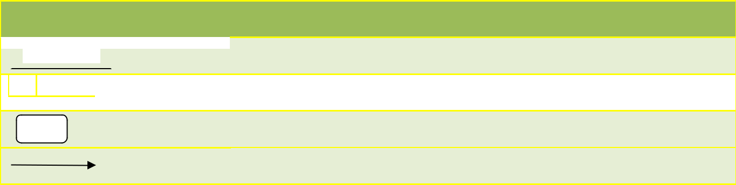

**Symbol** **Meaning**

 Entity e.g. user, branch, suspects.

A data store.

Process

A data flow.

**4.3.2 APPLICATION FLOWCHART**

Start

Login

Enter username and Password

Is Login?

No

Yes

Dashboard

Menu options: Child abuse list and case report

Is menu clicked?

No

Yes

Open link

Stop

**4.3.3 SYSTEM FLOWCHART**

###### Child Abuse Management System

# Processor

Disk

Storage

Output (Report)

Result to Screen

Input From the

Keyboard

Control Unit

**CHILD ABUSE MANAGEMENT SYSTEM**

Drug

The physical design of a system is concerned the actual physical implementation of the logical design as already discussed earlier. This section describes the actual processes of inputting, verifying and storing the in Child Abuse Management System, physical layout of the data stores, report formats and relation database management system used. During the physical design process, the researcher had to translate the expected schemas into actual database structures mapping the, entities to tables, relationships to foreign key, attributes to columns, primary unique identifiers to primary key constraints and unique identifiers to unique key constraints with the help of Mysql Database Software on which was used for the Data storage for the system.

The following were the different physical design;

**Table 3: Showing complaint table;**

|  |  |  |
| --- | --- | --- |
| S/N | Names | Type |
| 1 | User id | VARCHAR |
| 2 | Title | VARCHAR |
| 3 | Response | VARCHAR |
| 4 | Body | VARCHAR |

**Table 4: Showing notification table;**

|  |  |  |
| --- | --- | --- |
| S/N | Names | Type |
| 1 | Id | Int |
| 2 | title | Varchar |
| 3 | body | text |
| 4 | Created at | VARCHAR |
| 5 | country | Varchar |

**Table 5: showing users;**

|  |  |  |
| --- | --- | --- |
| S/N | Names | Type |
| 1 | Id | Int |
| 2 | name | Varchar |
| 3 | emailaddress | Varchar |
| 4 | phonenumber | Varchar |
| 5 | Username | varchar |
| 6 | Password | varchar |
| 7 | Address | text |
| 8 | State | varchar |
| 9 | gender | varchar |

**4.5.0 Getting Started with Child Abuse Management System**

After the systems final coding for the perfection of what is expected from it, it was turned into an executable file which can enable it be installed on any machine without PHP. So as to help make the system perform its functionalities’ with just its installation on any machine with the requirement per mentioned in Chapter III of the Report, all the installation files are copied into one directory in the programme files and short cut icon is places on the desktop.

**4.5.1 The Start up of the System**

The startup is simple as normal programs on which with just a double click on the short cut “Child Abuse Management System”, a screen will show up indicating the log on form on which requires credentials to continue using the system.

Security of information is the first thing each manager will put into consideration, in any system to be used by more than one person for example in an organization like a hospital, companies and others that contain lots of important information. There for the researcher came up with a login form that permits use of the system, on which none authorized users can access the system. Only valid users with correct user name and password can log into the system.

**4.5.2 System Interfaces**

**Figure 1: Login Form Screen**

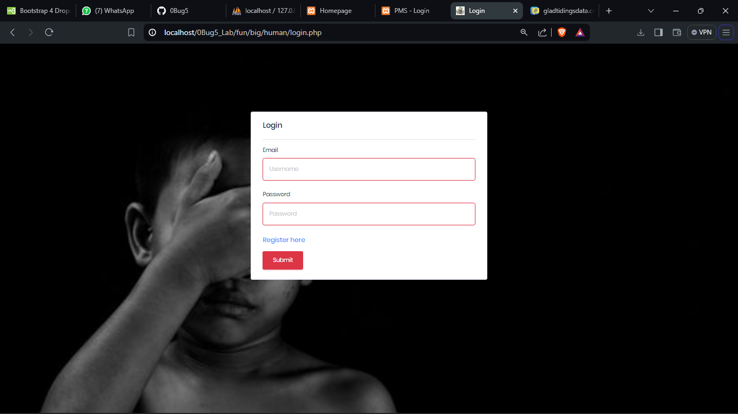

The login form is presented with two text boxes and two command buttons as shown in the figure above. Enter the correct user name and password in their respective text boxes and then click the “OK” command button or else click “Cancel” command button on which will cancel the login form and you cannot access the system.

**Figure 2: Admin dashboard**

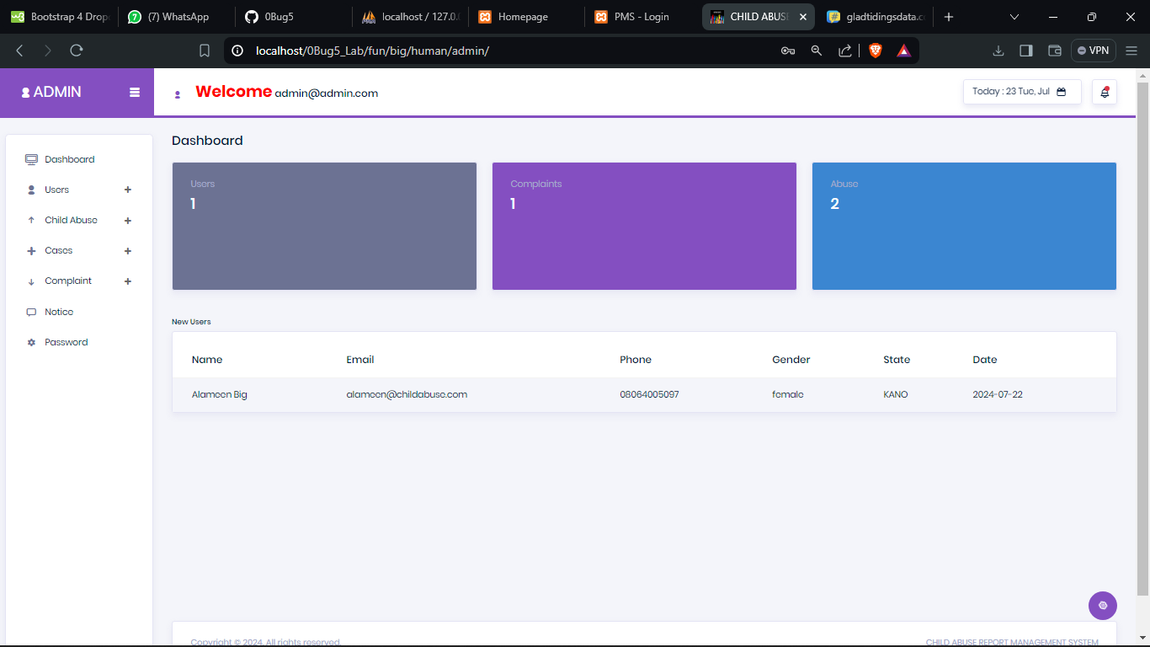

The main form acts as a navigation point of all pages of the system, through the main form, you can access any part of system depending on your level of authentication. Some legal users will not access some forms that are not in their area of concern. Only the administrator will be allowed to access everything in the system.

With the above figure it’s the main page on which every user goes to after the login, it contains most of the features in the system for example different privileges per the user for example editing users and other functionalities.

**Figure 3: Report abuse**

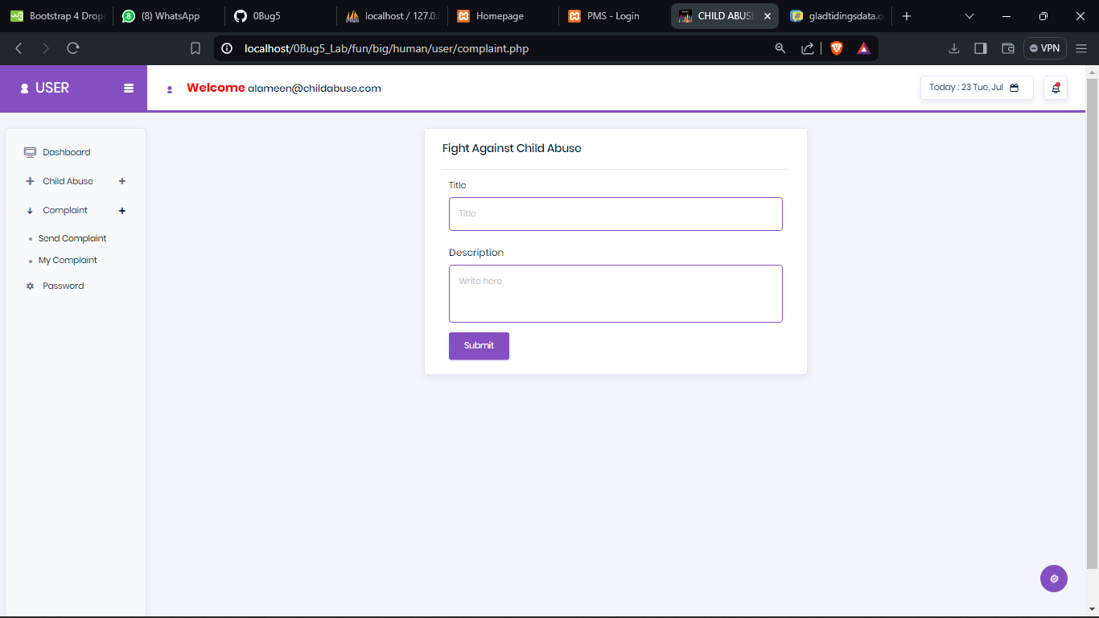

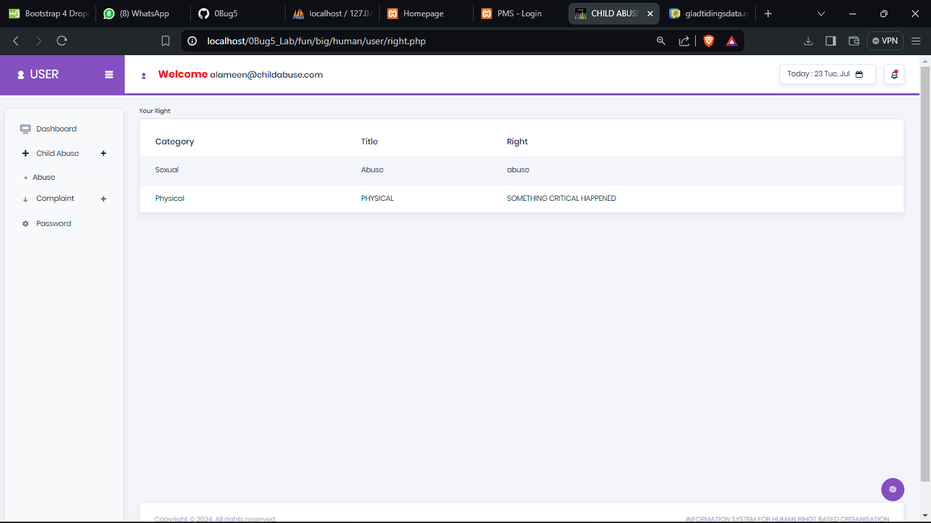

This is the form on which on which records all the information of patients.

**Figure 4: Abuse**

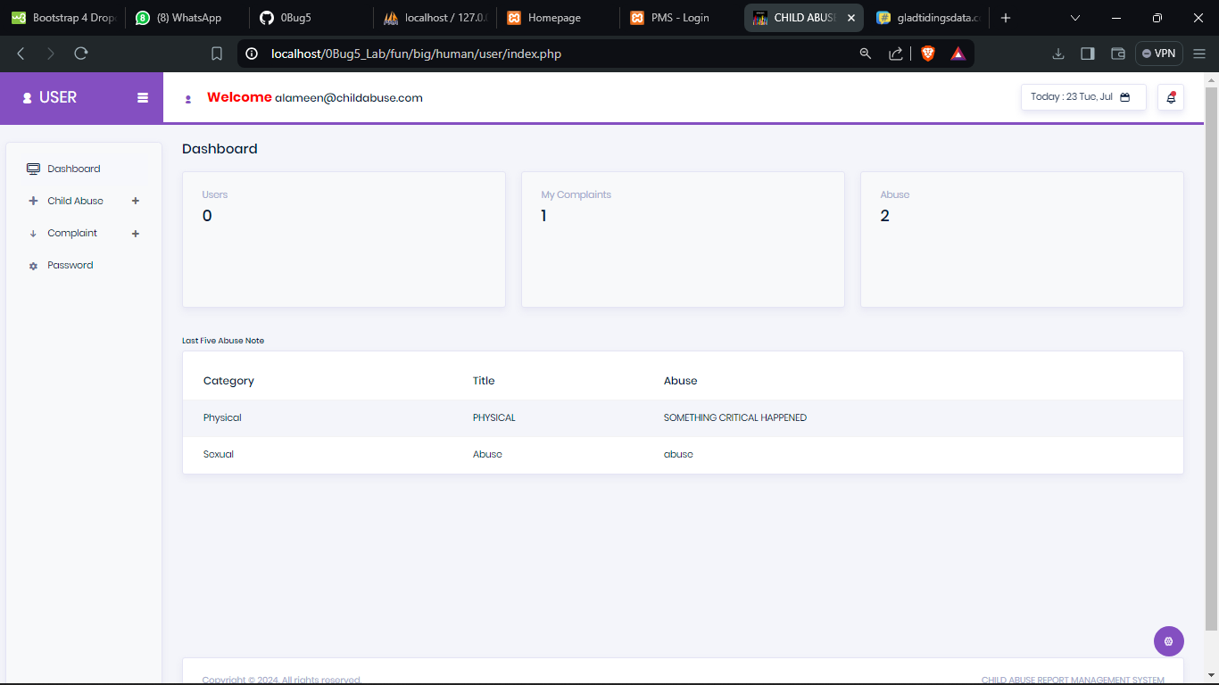

The above form is mainly used to enter the information of the abuse given to a child in different perspectives, for example, the abuse type, abuser’s information, reporter’s information, and reported station info.

**Figure 5: Change password**

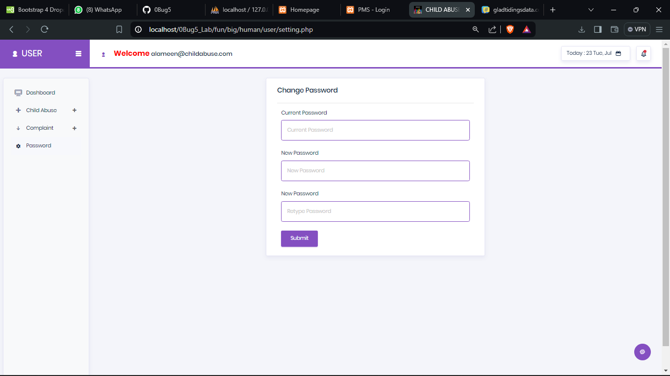

With this form, it makes the user or admin to change their profile information.

**Figure 6: Home page**



The above figure indicates the ways on case report of each abuse.

**CHAPTER FIVE**

**DISCUSSION, CONCLUSION AND RECOMMENDATION**

**5.0 Introduction**

This chapter gives a summary of the entire system with emphases on its achievements and limitations. There are also suggestions on possible areas of enhancement.

**5.1 Discussion**

The system was designed to fulfill the basic aim and specific objectives that were proposed at the earlier stage of the system development. A system comprises of people, equipment, space and procedures. The researcher was mindful of the input, processing, storing and retrieving requirements necessary for an effective system.

In any software development, security is always a very important issue for consideration. The administrators should therefore make use of authorized persons to take charge of the system. It is thus management obligation to ensure internal controls and security about the system, the system cannot be accessed by any user except the authorized user with the login ID and password.

**5.2 Limitations**

It is not usually possible to design a system that meets the needs of every user, therefore the system has the following limitations;

There are fixed queries that have been designed by the researcher. This means that the users cannot run queries of their choice unless the system is upgraded.

Project was quite limited since the project entails some components that required to be delivered on time with full functionality

Biased responses from some of the interviewees.

Lack of interest from some of the would-be users of the new system due to fear of loss of jobs as a result of the automation that the new system inhibits.

**5.3 Problems Encountered**

There are as many problems encountered as a system is one of the tasks on which needs much of attention, thus the following problems were encountered during the development process of coming up with the System;

* One of the biggest problem encountered on which it’s more so a general problem per all students that were carrying out project at the university was limitation in time to enable development of a program with better features. On which we were first given some desirable deadline at fast that was handing in over early September and on which was abruptly changed to a nearby date thus leading to compression of functionalities that would be included in the system due to limited time.
* In accessibility to the most current literature on software development Despite the normal programming procedures followed, some segments could not run normally especially in the viewing forms, may be due to computer memory problem since PHP takes allot of memory.
* Another encountered problem was limited access to better resources that were used in developing the system, specifically designing software’s like Edrawer, Ud on which internet access was always on and off thus even though they were downloaded the best that could be got were trial versions on which worked for 15 – 30 days hence disorganizing the researchers plans to come up with more unique and high performance system.
* The other encountered problem was on research or requirements engineering on which needed a lot of information from the medical center on which the research place was always Busy thus limited attention was given to the researcher since it was a big medical center they worked 24 hrs a day leading to getting most requirements from observation and the least through one on one interviews.
* Lack of proper documentation about the existing system was another problem encountered on which was a big bottleneck for System development.
* During data collection process, the staff was reluctant to release any information, as it was even hard for the researcher to be given sample forms that were used to be used in child abuse management Services with the fear that they might be supporting a competitor.

**5.4 Recommendations**

First of all, it’s important that Child Safety Monitoring Center continues to use the old manual system alongside per speculations in the implementation section in the report as the health Centre has many clients and the system users have to be trained to use the system as they may lose information on which may be of great use, thus the users should first use the manual and the automated system parallel till knowledge that the automated system is worth their expectations.

Similarly as mentioned above, the users need to be trained on how best they can use the new automated system. Users with basic computer skills will be required in order for them to appreciate the functionality of the program.

The system has a lot of room for further improvement though as it stands it can be used as a prototype to develop a Child Abuse Management System and more features could be added, since less time was available for the researcher.

Lastly on the recommendation as hinted before in supplements of the recommendations about the limited time, the report is not containing all that is in the Project system as it was still under construction and the due to need of beating the deadline of Report handing in most of the Parts needed were included in the Report Living out little bits on which were under construction and changes will be made after the completion of the system by 26th of July.

**5.4 Conclusion**

In each child who comes into this world, the hopes and dreams on human race are born a new. Children are bearers of our basic future a future that is in our hand as at no other time. For the world has the information, resources and the legal goals to give each child the best possible start in life, in family environments that offer the love, the care and the maturing that children need to grow, to learn and to develop to the fullest.

Yet still, these children are being exposed to all different types of mistreatments ranging from child labor, violence, abuse, neglect and commercial sexual misuse of children. Children are more vulnerable than adults to being hurt, neglected, abused and exploited. Their survival is in danger and their full improvement is compromised. Violence against children happens inside families, in schools and communities.

In any case, the need to care for these children in order to meet the increasing and difficulty request emerged. Therefore, man resolves to help to mobilize a Global development for children an unstoppable crusade to end, finally, the poverty, ill health, violence and discrimination that have needlessly blighted and destroyed so many young lives. In this juncture, there is have to know who a child is andwhat child abuse and neglect is “there isn’t one acceptable age,which is considered as a commendable meaning of the upper limit of childhood begins as far as the privilege to vote and be voted in favor of and the age thought about the government service of youth and culture, and education as being upper limit of childhood differs… “ even internationally, there are dissimilar definitions as to who a child seems to be. The OAU sanction characterizes a child as “each person below the ages of eighteen (18) years” despite the fact that there are divergent opinions and view with respect to what is the age limit of a child, it is the view of the author, that a child is anyone between the birth to the fruition of physiological/mental and physical improvement. As it were, anyone between zero of his/her introduction to the world to eighteen (18) years is a CHILD.

Child disregard is implied demonstration of oversight, dissent or notwithstanding giving essential needs, rights and deeds of the child by parents/ guardians which might possibly fundamentally disable the prosperity of a child. Disregard can likewise appear as insufficient arrangement of resources for the welfare of the child both now and in future.

child mind then again speaks to a region of programming focused at “child needing special protection measures”. There are child who are victims of or belong to, groups which are especially vulnerable to, various kinds of abuse, exploitation, violence and abandonment.

Vulnerable groups-incorporate children armed conflict or by other situations of emergency, children engaged in hazardous or exploitative labour, including those who are trafficked, children deprived of parental protection due to AIDS, children subjected to sexual exploitation and abuse, children living with disabilities and children in conflict with the law.

On account of the above situations, communities should be strengthened and families bolstered to give the vital care to enhance child survival, improvement. Families require learning, aptitudes, inspiration and support, they have to recognize what to do in particular conditions and ass the child develop and create, they require aptitudes to give suitable care and to take care of issues. They should be roused to attempt and to manage new practices. They require social and material help shape the network. Lastly require bolster frame the health centers/system, in the form of accessible clinics responsible services and health workers should have to give effective advice, drugs, and more complex treatment when necessary.

**REFERENCES**

1. Braker, Stone M & J.M Hellerstein (eds.) (1998). ”Reading in databases”. *Kaufmann San* *Francisco*
2. Hallmark, J; Garcia, C (1992). System migration experiences from the field. Information Technology & libraries, 11 (4), 345-358.
3. Hudgins, J; and Macklin, L. (2000). New materials, new processes: implementing digital imaging projects into existing work flow. Library collections, Acquisitions, &Technical services, 24(2), 189-204.
4. Laudon. Kand Laudon J (2002) management information systems, 7th Edition, Pearson Education Asia
5. Lewis. C. and Griffin M. (1997),, Human factors consideration in clinical applications of virtual reality.
6. Riva. G., (1999), Virtual Reality as a communication tool: a socio-cognitive analysis Teleoperators, and Virtual Environments
7. Siau, Keng (2003). *Advanced topics in database research*, volume 5
8. Shortell SM, Gillies RR, Anderson DA, Erickson KM, Mitchell JB. Remaking health care in America. San Francisco:

9. Yaspan, Arthur (1961). *Operation Research*. Vol 9, pp. 371-38

**APPENDICES:**

**Interview Guide**

**Questions**

1. What are the strength of the current system on which the Child Safety Monitoring Center is using in line with the Child Abuse Management System?

……………………………………………………………………………………………

……………………………………………………………………………………………

……………………………………………………………………………………………

……………………………………………………………………………………………

……………………………………………………………………………………………

……………………………………………………………………………………………

……………………………………………………………………………………………

……………………………………………………………………………………………

………………………………………………….

1. What are its weaknesses in details?

……………………………………………………………………………………………

……………………………………………………………………………………………

……………………………………………………………………………………………

……………………………………………………………………………………………

……………………………………………………………………………………………

……………………………………………………………………………………………

……………………………………………………………………………………………

……………………………………………………………………………………………

……………………

36

1. What are the limitations of the current system used in the child monitoring center per Child Abuse Management?

……………………………………………………………………………………………

……………………………………………………………………………………………

……………………………………………………………………………………………

……………………………………………………………………………………………

……………………………………………………………………………………………

……………………………………………………………………………………………

……………………………………………………………………………………………

……………………………………………………………………………………………

……………………

1. What are the problems faced by the current system?

……………………………………………………………………………………………

……………………………………………………………………………………………

……………………………………………………………………………………………

……………………………………………………………………………………………

……………………………………………………………………………………………

……………………………………………………………………………………………

……………………………………………………………………………………………

……………………………………………………………………………………………

………………………………………………….

1. How would you want the new system to work per its perfection?

……………………………………………………………………………………………

……………………………………………………………………………………………

……………………………………………………………………………………………

……………………………………………………………………………………………

……………………………………………………………………………………………

……………………………………………………………………………………………

……………………………………………………………………………………………

37

……………………………………………………………………………………………

……………………

* What are the main features that you may want to be included in the new system?

……………………………………………………………………………………………

……………………………………………………………………………………………

……………………………………………………………………………………………

……………………………………………………………………………………………

……………………………………………………………………………………………

……………………………………………………………………………………………

……………………………………………………………………………………………

……………………………………………………………………………………………

……………………

* Who is supposed to be given what privilege per the activities in the Child Safety Monitoring Center in details, for example who is supposed to fill the Child Abuse information, or who is supposed to record the details?

……………………………………………………………………………………………

……………………………………………………………………………………………

……………………………………………………………………………………………

……………………………………………………………………………………………

……………………………………………………………………………………………

……………………………………………………………………………………………

……………………………………………………………………………………………

……………………………………………………………………………………………

……………………

38

……………………………………………………………………………………………

……………………………………………………………………………………………

……………………………………………………………………………………………

……………………………………………………………………………………………

……………………………………………………………………………………………

……………

*Thank you*

Aber, J.L., and Cicchetti, D (2014) The socio-emotional development of maltreated children: An empirical and theoretical analysis. Pp. 147-205 in H. Fitzgerald, B. Lester, and M. Yogman (eds.) *Theory and Research in Behavioral Pediatrics* Vol. II. New York: Plenum Press.

Abram, K. (2010) The problem of co-occurring disorders among jail detainees: Antisocial disorder, alcoholism, drug abuse, and depression. *Law and Human Behavior* 14:333-345.

Alessandri, S.M. (2011) Play and social behavior in maltreated preschoolers. *Development and Psycopathology* 3:191-205.

Alfaro, J.D (2011) Report on the relationship between child abuse and neglect and later socially deviant behavior. In R.J. Hunner and Y.E. Walker, eds., *Exploring the Relationship Between Child Abuse and Delinquency*. Montclair, NJ: Allanheld, Osmun.

Allen, D.M (2010) Young male prostitutes: A psychosocial study. *Archives of Sexual Behavior* 9:399-426.

Augoustinos, M. (2010) Developmental effects of child abuse: A number of recent findings. *Child Abuse and Neglect* 11:15-27.

Ayoub, C.C., and Milner S.S. (2015) Failure to thrive parental indicators, types, and outcome. *Child Abuse and Neglect* 9:491-499.

Barahal, R.M (2010) The social and cognitive development of abused children. *Journal of Consulting and Clinical Psychology* 53:335-343.

Bath, H. I., and Haapala. D. A (2013). “Intensive Family Preservation Services with Abused and Neglected Children: An Examination of Group Differences.” *Child Abuse* & *Neglect* 17(2): 213–225.

Beck, J.C (2010) Reports of childhood incest and current behavior of chronically hospitalized psychotic women. *American Journal of Psychitary* 144(11):1474-1476.

Benward, J., and Densen-Gerber, J (2015) Incest as a causative factor in antisocial behavior. *Contemporary Drug Problems* 4:323-340.

Berger, L. M. (2010). “Socioeconomic Factors and Substandard Parenting.” *Social Service Review* 81(3): 485–522.

Berger, L. M. (2014). “Income, Family Structure, and Child Maltreatment Risk.” *Children and Youth Services Review* 26(8): 725–748.

Berger, L. M. (2015). “Income, Family Characteristics, and Physical Violence toward Children.” *Child Abuse & Neglect* 29(2): 107–133.

Bloom, H. S. (2011). *The Core Analytics of Randomized Experiments for Social Research*. New York: Manpower Demonstration Research Corporation.

Bonomi, R. S (2008). Association between self-reported health and physical and/or sexual abuse experienced before age 18. Child Abuse & Neglect, 32(7), 693-701.

Brown and Salzinger. S (2010). “A Longitudinal Analysis of Risk Factors for Child Maltreatment: Findings of a 17-Year Prospective Study of Officially Recorded and Self-Reported Child Abuse and Neglect.” *Child Abuse & Neglect* 22(11): 1065–1078.

Cancian, M and Caspar, E (2008). “Welfare and Child Support: Complements, not Substitutes.” *Journal of Policy Analysis and Management* 27(2): 354–375.

Chaffin, M (2011). “Onset of Physical Abuse and Neglect: Psychiatric, Substance Abuse, and Social Risk Factors from Prospective Community Data.” *Child Abuse & Neglect* 20(3): 191–203.

Corso, P and Mercy, J. A (2011). “Health-Related Quality of Life among Adults Who Experienced Maltreatment during Childhood.” *American Journal of Public Health* 98(6): 1094.

Crouch, J. L and Milner, J. S. (2013). Effects of child neglect on children. Criminal Justice and Behavior, 20(1), 49-65. doi:10.1177/0093854893020001005

Culp, R. E (2011). Maltreated children's language and speech development: Abused, neglected, and abused and neglected. First Language, 11(33), 377-389. Dykes, J.P (2010) The effects of maltreatment on young children's socioemotional development: An attachment theory perspective. *Developmental Psychology* 23:406-414.

Drotar, J.L, (2012) The effects of maltreatment on development during early childhood: Recent studies and their theoretical, clinical and policy implications. Pp. 579-619 in D. Cicchetti and V. Carlson (eds.) *Child Maltreatment: Theory and Research on Causes and Consequences*. New York: Cambridge University Press.

Gilbert, U and Janson, U (2009). “Burden and Consequences of Child Maltreatment in High-Income Countries.” *The Lancet* 373(9657): 68–81.

Gillham, B (2010). “Unemployment Rates, Single Parent Density, and Indices of Child Poverty: Their Relationship to Different Categories of Child Abuse and Neglect.” *Child Abuse & Neglect* 22(2): 79–90.

Gornick, J. C. and Meyers, M. K (2015). *Families that Work: Policies for Reconciling Parenthood and Employment*. New York: Russell Sage Foundation.

Greenfield, E. A. (2010). Child abuse as a life-course social determinant of adult health. Maturitas, 66(1), 51-55. doi:DOI: 10.1016/j.maturitas.2010.02.002

Jacobson, S.T (2010) Developmental outcomes in abused children: Consequences of parental abuse or a more general breakdown in caregiver behavior? *Behavior Therapist* 11:27-32.

Jones, E. D., and McCurdy, K (2012). “The Links between Types of Maltreatment and Demographic Characteristics of Children.” *Child Abuse & Neglect* 16(2): 201–215.

Jones, L. (2010). “Unemployment and Child Abuse.” *Families in Society* 71(10): 579–588.

Larkin, H. (2009). Adverse childhood experiences linked to health risk behaviors. Policy and Practice of Public Human Services, 67(3), 14-16.

Patterson, J.H (2009) A review of the short-term effects of childhood sexual abuse. *Child Abuse and Neglect* 15:537-556.

Rosenbaum, J.V (2011) Characteristics of adolescent incest sexual perpetrators: Preliminary findings. *Journal of Family Violence* 1(1):85-97.

Stovall, K (2010) Depressive characteristics of physically abused children. *Journal of Abnormal Child Psychology* 17:1-11.

Sylvestre, A and Mérette, C. (2010). Language delay in severely neglected children: A cumulative or specific effect of risk factors? Child Abuse & Neglect, 34(6), 414-428.

Trickett, P. K and McBride-Chang, C. (2015). The developmental impact of\ different forms of child abuse and neglect. Developmental Review 15, 311-337.

Twardosz, S and Lutzker, J. R. (2010). Child maltreatment and the developing brain: A review of neuroscience perspectives. Aggression and Violent Behavior, 15(1), 59-68. d

Vissing J.M (2012) The effects of child maltreatment on language development. *Child Abuse and Neglect* 6:299-305.

Woodhouse, B. B. (2011). Implications for children's rights in the united states. *An introduction to children's rights, 25-29.s*

**SOURCE CODE**

**abuselist.php**

**<?php require_once** (**"header.php"**)**?>***<!-- Page Heading -->*<**div class="row"**>  
 <**div class="col-lg-12"**>  
 <**h1 class="page-header"**>  
 Child Abuse <**small**>List of Child Abuse</**small**>  
 </**h1**>  
 <**button class="btn btn-primary" type="button" data-target="#modalAbuseInfo" data-toggle="modal"**>New Abuse</**button**>  
 </**div**>  
</**div**>  
*<!-- /.row -->*<**br**><**br**>  
  
  
<**div class="row"**>  
 <**div class="col-lg-12 col-md-12"**>  
 <**div class="panel panel-default"**>  
 <**div class="panel-heading"**>  
 <**h4 class="panel-title text-center"**>List of Child Abuse</**h4**>  
 </**div**>  
 <**div class="panel-body"**>  
 <**div class="table-responsive"**>  
 <**table class="table"**>  
 <**thead**>  
 <**tr**>  
 <**th**>S/N</**th**>  
 <**th**>Date</**th**>  
 <**th**>Abuse ID</**th**>  
 <**th**>Type of Abuse</**th**>  
 <**th**>Abuse Name</**th**>  
 <**th**>Reporter</**th**>  
 <**th**>Reported to</**th**>  
 <**th**>Status</**th**>  
 <**th**>Action</**th**>  
 </**tr**>  
 </**thead**>  
 <**tbody**>  
 **<?php** $sql = **"SELECT** *\** **FROM abuse WHERE status='None' order by id desc"**;  
 $result = $conn->query($sql);  
 $count=1;  
 **if** ($result->**num_rows** > 0) {  
 *// output data of each row* **while**($row = $result->fetch_assoc()) {  
 **echo "<tr>"** ;  
 **echo "<td>"**.$count++.**"</td>"**;  
 **echo "<td>"**.$row[**"datecreated"**].**"</td>"**;  
 **echo "<td>"**.$row[**"abuse_id"**].**"</td>"**;  
 **echo "<td>"**.$row[**"type_abuse"**].**"</td>"**;  
 **echo "<td>"**.$row[**"abuse_by_name"**].**"</td>"**;  
 **echo "<td>"**.$row[**"reporter_name"**].**"</td>"**;  
 **echo "<td>"**.$row[**"person_incharge"**].**"</td>"**;  
 **echo "<td>"**.$row[**"status"**].**"</td>"**;  
 **echo "<td><a href='abuselist.php?abuselistview="**. $row[**'id'**] .**"' title='View' data-toggle='tooltip' class='btn btn-primary'>View</a>"**;  
 **echo" <div class=\"dropdown\">  
 <button class=\"btn btn-primary dropdown-toggle\" type=\"button\" data-toggle=\"dropdown\">  
 <span class=\"fa fa-cog\"></span>  
 <span class=\"caret\"></span>  
 </button>  
 <ul class=\"dropdown-menu\">  
<li><a href='abuselist.php?abuselistforward="**. $row[**'id'**] .**"' title='Pending Case' data-toggle='tooltip'>Pending Case</a></li>  
<li><a href='abuselist.php?abuselistabandoned="**. $row[**'id'**] .**"' title='Pending Case' data-toggle='tooltip'>Abandoned Case</a></li>  
<li><a href='abuselist.php?abuselisttreat="**. $row[**'id'**] .**"' title='Pending Case' data-toggle='tooltip'>Treat Case</a></li>  
<li><a href='abuselist.php?abuselistresolved="**. $row[**'id'**] .**"' title='Pending Case' data-toggle='tooltip'>Resolved Case</a></li>  
 </ul>  
 </div>"**;  
 *// echo "";* **echo "<a href='abuselist.php?abuselistedit="**. $row[**'id'**] .**"' title='Edit' data-toggle='tooltip' class='btn btn-default'>Edit</a>"**;  
 **echo "<a href='abuselist.php?abuselistdelete="**. $row[**'id'**] .**"' title='Delete' data-toggle='tooltip' class='btn btn-danger'>Delete</a>"**;  
 **echo "</td>"**;  
 **echo "</tr>"** ;  
 }  
 } **else** {  
 **echo "<tr>"** ;  
 **echo "<td colspan='5'><center>0 results</center></td>"**;  
 **echo "</tr>"** ;  
 }  
 *// $conn->close();* **?>** </**tbody**>  
 </**table**>  
 </**div**>  
 </**div**>  
 </**div**>  
 </**div**>  
</**div**>  
*<!---Child Info modal--->*<**div class="modal fade" id="modalAbuseInfod" role="dialog"**>  
 <**div class="modal-dialog"**>  
 <**div class="modal-content"**>  
 <**div class="modal-header"**>  
 <**button class="close" data-dismiss="modal"**>**&times;**</**button**>  
 <**h4 class="modal-title"**>View Abuse Information</**h4**>  
 </**div**>  
 <**div class="modal-body"**>  
 <**div class="form-group"**>  
 <**label class="control-label"**>Abuse ID</**label**>  
 <**br**>  
 <**span class="control-label"**>**<?php echo** $txtAbuseLisID ; **?>**</**span**>  
 </**div**>  
 <**div class="form-group"**>  
 <**label class="control-label"**>Type of Abuse</**label**>  
 <**br**>  
 <**span class="control-label"**>**<?php echo** $txtTypeofAbuse ; **?>**</**span**>  
 </**div**>  
 <**div class="form-group"**>  
 <**label class="control-label"**>Abuse</**label**>  
 <**br**>  
 <**span class="control-label"**>**<?php echo** $txtAbuse ; **?>**</**span**> </**div**>  
 <**div class="form-group"**>  
 <**label class="control-label"**>Abuse by Name</**label**>  
 <**br**>  
 <**span class="control-label"**>**<?php echo** $txtAbuseName ; **?>**</**span**>  
 </**div**>  
 <**div class="form-group"**>  
 <**label class="control-label"**>Abuse by Address</**label**>  
 <**br**>  
 <**span class="control-label"**>**<?php echo** $txtAbuseAddress ; **?>**</**span**>  
 </**div**>  
 <**div class="form-group"**>  
 <**label class="control-label"**>Abuse by Phone number</**label**>  
 <**br**>  
 <**span class="control-label"**>**<?php echo** $txtAbusePhonenumber ; **?>**</**span**>  
 </**div**>  
 <**div class="form-group"**>  
 <**label class="control-label"**>Abuse by Email address</**label**>  
 <**br**>  
 <**span class="control-label"**>**<?php echo** $txtAbuseEmailAddress ; **?>**</**span**>  
 </**div**>  
 <**div class="form-group"**>  
 <**label class="control-label"**>Abuse by State</**label**>  
 <**br**>  
 <**span class="control-label"**>**<?php echo** $txtAbuseState ; **?>**</**span**>  
 </**div**>  
 <**div class="form-group"**>  
 <**label class="control-label"**>Abuse by Country</**label**>  
 <**br**>  
 <**span class="control-label"**>**<?php echo** $txtAbusecountry ; **?>**</**span**>  
 </**div**><**hr**>  
 <**h4**>Reported to:</**h4**>  
 <**div class="form-group"**>  
 <**label class="control-label"**>Reported Station</**label**>  
 <**br**>  
 <**span class="control-label"**>**<?php echo** $txtReportedStation ; **?>**</**span**>  
 </**div**>  
 <**div class="form-group"**>  
 <**label class="control-label"**>Reported Address</**label**>  
 <**br**>  
 <**span class="control-label"**>**<?php echo** $txtReportedAddress ; **?>**</**span**>  
 </**div**>  
 <**div class="form-group"**>  
 <**label class="control-label"**>Person Incharge</**label**>  
 <**br**>  
 <**span class="control-label"**>**<?php echo** $txtPersonIncharge ; **?>**</**span**>  
 </**div**>  
 <**div class="form-group"**>  
 <**label class="control-label"**>Phone number</**label**>  
 <**br**>  
 <**span class="control-label"**>**<?php echo** $txtPhonenumber ; **?>**</**span**>  
 </**div**>  
 <**div class="form-group"**>  
 <**label class="control-label"**>Email address</**label**>  
 <**br**>  
 <**span class="control-label"**>**<?php echo** $txtEmailaddress ; **?>**</**span**>  
 </**div**>  
 <**div class="form-group"**>  
 <**label class="control-label"**>Contact Address</**label**>  
 <**br**>  
 <**span class="control-label"**>**<?php echo** $txtContactAddress ; **?>**</**span**>  
 </**div**>  
 <**div class="form-group"**>  
 <**label class="control-label"**>State</**label**>  
 <**br**>  
 <**span class="control-label"**>**<?php echo** $txtState ; **?>**</**span**>  
 </**div**>  
 <**div class="form-group"**>  
 <**label class="control-label"**>Country</**label**>  
 <**br**>  
 <**span class="control-label"**>**<?php echo** $txtCountry ; **?>**</**span**>  
 </**div**>  
 <**hr**>  
 <**h4**>Reporter information</**h4**>  
 <**div class="form-group"**>  
 <**label class="control-label"**>Name of Reporter</**label**>  
 <**br**>  
 <**span class="control-label"**>**<?php echo** $txtNameofReporter ; **?>**</**span**>  
 </**div**>  
 <**div class="form-group"**>  
 <**label class="control-label"**>Phone number</**label**>  
 <**br**>  
 <**span class="control-label"**>**<?php echo** $txtReporterPhonenumber ; **?>**</**span**>  
 </**div**>  
 <**div class="form-group"**>  
 <**label class="control-label"**>Email Address</**label**>  
 <**br**>  
 <**span class="control-label"**>**<?php echo** $txtReporterEmail ; **?>**</**span**>  
 </**div**>  
 <**div class="form-group"**>  
 <**label class="control-label"**>Contact Address</**label**>  
 <**br**>  
 <**span class="control-label"**>**<?php echo** $txtReporterContactAddress ; **?>**</**span**>  
 </**div**>  
 <**div class="form-group"**>  
 <**label class="control-label"**>State</**label**>  
 <**br**>  
 <**span class="control-label"**>**<?php echo** $txtReporterState ; **?>**</**span**>  
 </**div**>  
 <**div class="form-group"**>  
 <**label class="control-label"**>Country</**label**>  
 <**br**>  
 <**span class="control-label"**>**<?php echo** $txtReporterCountry ; **?>**</**span**>  
 </**div**>  
 </**div**>  
 <**div class="modal-footer"**>  
 <**a href="abuselist.php" class="btn btn-primary" name="btnSubmit"**>Submit</**a**>  
 <**a href="abuselist.php" class="btn btn-danger" name="btnCancel"**>Cancel</**a**>  
 </**div**>  
 </**div**>  
 </**div**>  
</**div**>  
*<!---End of Abuse List Modal--->*<**form id="frmChildren" action="abuselist.php" method="post"**>  
*<!---Child Info modal--->*<**div class="modal fade" id="modalAbuseInfo" role="dialog"**>  
 <**div class="modal-dialog"**>  
 <**div class="modal-content"**>  
 <**div class="modal-header"**>  
 <**button class="close" data-dismiss="modal"**>**&times;**</**button**>  
 <**h4 class="modal-title"**>Edit Abuse Information</**h4**>  
 </**div**>  
 <**div class="modal-body"**>  
 <**div class="form-group"**>  
 <**label class="control-label"**>Abuse ID</**label**>  
 <**select class="form-control" name="cmbAbuseID"**>  
 **<?php** $sql = **"SELECT** *\** **FROM children"**;  
 $result = $conn->query($sql);  
 **if** ($result->**num_rows** > 0) {  
 *// output data of each row* **while**($row = $result->fetch_assoc()) {  
  
 **if**($txtAbuseLisID ==$row[**"abuse_id"**]){  
 **echo "<option selected>"**. $txtAbuseLisID .**"</option>"**;  
 }**else**{  
 **echo "<option>"**.$row[**"abuse_id"**].**"</option>"**;  
 }  
 }  
  
 }  
 **?>** </**select**>  
 </**div**>  
 <**div class="form-group"**>  
 <**label class="control-label"**>Type of Abuse</**label**>  
 <**select class="form-control" name="cmbTypeofAbuse"**>  
 <**option**>Physical Abuse</**option**>  
 <**option**>Emotional Abuse</**option**>  
 <**option**>Sexual Abuse</**option**>  
 <**option**>Neglect</**option**>  
 **<?php  
 if**($txtTypeofAbuse){  
 **echo "<option selected>"**. $txtTypeofAbuse .**"</option>"**;  
 }  
 **?>** </**select**>  
 </**div**>  
 <**div class="form-group"**>  
 <**label class="control-label"**>Abuse</**label**>  
 <**select class="form-control" name="cmbAbuse"**>  
 <**option**>Hitting</**option**>  
 <**option**>Shaking</**option**>  
 <**option**>Choking</**option**>  
 <**option**>Smothering</**option**>  
 <**option**>using physical restraints</**option**>  
 <**option**>Throwing</**option**>  
 <**option**>Burning</**option**>  
 <**option**>Biting</**option**>  
 <**option**>Poisoning</**option**>  
 <**option**>Not providing appropriate food, clothing, or medical care</**option**>  
 <**option**>Locking a child in a room or closet</**option**>  
 <**option**>Not providing adequate shelter, including abandoning a child or excluding them from the family home</**option**>  
 <**option**>Placing or leaving the child in a situation in which they might experience emotional or physical danger or harm</**option**>  
 <**option**>Leaving a child alone for a long time or so that they experience harm</**option**>  
 <**option**>Rape</**option**>  
 <**option**>Sexual dressing</**option**>  
 <**option**>Not allowing children to express their views and opinions</**option**>  
 <**option**>Ridiculing</**option**>  
 <**option**>Threatening</**option**>  
 <**option**>Silent treatment</**option**>  
 <**option**>Mocking</**option**>  
 <**option**>Bullying</**option**>  
 <**option**>Emotional blackmail</**option**>  
 **<?php  
 if**($txtAbuse){  
 **echo "<option selected>"**. $txtAbuse .**"</option>"**;  
 }  
 **?>** </**select**> </**div**>  
 <**div class="form-group"**>  
 <**label class="control-label"**>Abuse by Name</**label**>  
 <**input class="form-control" name="txtAbuseName" type="text" value="<?php echo** $txtAbuseName; **?>"**>  
 </**div**>  
 <**div class="form-group"**>  
 <**label class="control-label"**>Abuse by Address</**label**>  
 <**textarea class="form-control" name="txtAbuseAddress"**>**<?php echo** $txtAbuseAddress ; **?>**</**textarea**>  
 </**div**>  
 <**div class="form-group"**>  
 <**label class="control-label"**>Abuse by Phone number</**label**>  
 <**input class="form-control" name="txtAbusePhonenumber" type="text" value="<?php echo** $txtAbusePhonenumber; **?>"**>  
 </**div**>  
 <**div class="form-group"**>  
 <**label class="control-label"**>Abuse by Email address</**label**>  
 <**input class="form-control" name="txtAbuseEmailAddress" type="text" value="<?php echo** $txtAbuseEmailAddress; **?>"**>  
 </**div**>  
 <**div class="form-group"**>  
 <**label class="control-label"**>Abuse by State</**label**>  
 <**input class="form-control" name="txtAbuseState" type="text" value="<?php echo** $txtAbuseState; **?>"**>  
 </**div**>  
 <**div class="form-group"**>  
 <**label class="control-label"**>Abuse by Country</**label**>  
 <**input class="form-control" name="txtAbusecountry" type="text" value="<?php echo** $txtAbusecountry; **?>"**>  
 </**div**><**hr**>  
 <**h4**>Reported to:</**h4**>  
 <**div class="form-group"**>  
 <**label class="control-label"**>Reported Station</**label**>  
 <**input class="form-control" name="txtReportedStation" type="text" value="<?php echo** $txtReportedStation; **?>"**>  
 </**div**>  
 <**div class="form-group"**>  
 <**label class="control-label"**>Reported Address</**label**>  
 <**input class="form-control" name="txtReportedAddress" type="text" value="<?php echo** $txtReportedAddress; **?>"**>  
 </**div**>  
 <**div class="form-group"**>  
 <**label class="control-label"**>Person Incharge</**label**>  
 <**input class="form-control" name="txtPersonIncharge" type="text" value="<?php echo** $txtPersonIncharge; **?>"**>  
 </**div**>  
 <**div class="form-group"**>  
 <**label class="control-label"**>Phone number</**label**>  
 <**input class="form-control" name="txtPhonenumber" type="text" value="<?php echo** $txtPhonenumber; **?>"**>  
 </**div**>  
 <**div class="form-group"**>  
 <**label class="control-label"**>Email address</**label**>  
 <**input class="form-control" name="txtEmailaddress" type="text" value="<?php echo** $txtEmailaddress; **?>"**>  
 </**div**>  
 <**div class="form-group"**>  
 <**label class="control-label"**>Contact Address</**label**>  
 <**textarea class="form-control" name="txtContactAddress"**>**<?php echo** $txtContactAddress; **?>**</**textarea**>  
 </**div**>  
 <**div class="form-group"**>  
 <**label class="control-label"**>State</**label**>  
 <**input class="form-control" name="txtState" type="text" value="<?php echo** $txtState; **?>"**>  
 </**div**>  
 <**div class="form-group"**>  
 <**label class="control-label"**>Country</**label**>  
 <**input class="form-control" name="txtCountry" type="text" value="<?php echo** $txtCountry; **?>"**>  
 </**div**>  
 <**hr**>  
 <**h4**>Reporter information</**h4**>  
 <**div class="form-group"**>  
 <**label class="control-label"**>Name of Reporter</**label**>  
 <**input class="form-control" name="txtNameofReporter" type="text" value="<?php echo** $txtNameofReporter; **?>"**>  
 </**div**>  
 <**div class="form-group"**>  
 <**label class="control-label"**>Phone number</**label**>  
 <**input class="form-control" name="txtReporterPhonenumber" type="text" value="<?php echo** $txtReporterPhonenumber; **?>"**>  
 </**div**>  
 <**div class="form-group"**>  
 <**label class="control-label"**>Email Address</**label**>  
 <**input class="form-control" name="txtReporterEmail" type="text" value="<?php echo** $txtReporterEmail; **?>"**>  
 </**div**>  
 <**div class="form-group"**>  
 <**label class="control-label"**>Contact Address</**label**>  
 <**textarea class="form-control" name="txtReporterContactAddress"**>**<?php echo** $txtReporterContactAddress; **?>**</**textarea**>  
 </**div**>  
 <**div class="form-group"**>  
 <**label class="control-label"**>State</**label**>  
 <**input class="form-control" name="txtReporterState" type="text" value="<?php echo** $txtReporterState; **?>"**>  
 </**div**>  
 <**div class="form-group"**>  
 <**label class="control-label"**>Country</**label**>  
 <**input class="form-control" name="txtReporterCountry" type="text" value="<?php echo** $txtReporterCountry; **?>"**>  
 </**div**>  
 </**div**>  
 <**div class="modal-footer"**>  
 <**button class="btn btn-primary" name="btnSubmit"**>Submit</**button**>  
 <**button class="btn btn-danger" name="btnCancel"**>Cancel</**button**>  
 </**div**>  
 </**div**>  
 </**div**>  
</**div**>  
*<!---End of Abuse List Modal--->* <**input class="form-control" name="txtAbuseID" type="hidden" value="<?php echo** $txtAbuseID; **?>"**>  
</**form**>  
**<?php  
if**(**isset**($_POST[**'btnSubmit'**])) {  
 abuselist($_POST[**'cmbAbuseID'**],$_POST[**'cmbTypeofAbuse'**],$_POST[**'cmbAbuse'**],$_POST[**'txtAbuseName'**],$_POST[**'txtAbuseAddress'**],$_POST[**'txtAbusePhonenumber'**],$_POST[**'txtAbuseEmailAddress'**],$_POST[**'txtAbuseState'**],$_POST[**'txtAbusecountry'**],$_POST[**'txtReportedStation'**],$_POST[**'txtReportedAddress'**],$_POST[**'txtPersonIncharge'**],$_POST[**'txtPhonenumber'**],$_POST[**'txtEmailaddress'**],$_POST[**'txtContactAddress'**],$_POST[**'txtState'**],$_POST[**'txtCountry'**],$_POST[**'txtNameofReporter'**] ,$_POST[**'txtReporterPhonenumber'**],$_POST[**'txtReporterEmail'**],$_POST[**'txtReporterContactAddress'**],$_POST[**'txtReporterState'**],$_POST[**'txtReporterCountry'**],$_POST[**'txtAbuseID'**]);  
}  
**if**(**isset**($_POST[**'btnCancel'**])) {  
 *header*(**'location: abuselist.php'**);  
}  
**if**(**isset**($_GET[**'abuselistnew'**])){  
 **echo "<script type='text/javascript'>  
  
$('#modalAbuseInfo').modal('show');  
  
</script>"**;  
}  
**if**(**isset**($_GET[**'abuselistedit'**])){  
 **echo "<script type='text/javascript'>  
  
$('#modalChildInfo').modal('show');  
  
</script>"**;  
}  
**if**(**isset**($_GET[**'abuselistview'**])){  
 **echo "<script type='text/javascript'>  
  
$('#modalAbuseInfod').modal('show');  
  
</script>"**;  
}  
**if** (**isset**($_GET[**'abuselistabandoned'**])) {  
**echo"<script>  
 alert(\"Your request has been Abandoned\")  
</script>"**;  
}  
**if** (**isset**($_GET[**'abuselisttreat'**])) {  
 **echo"<script>  
 alert(\"Your request has been Treated\")  
</script>"**;  
}  
**if** (**isset**($_GET[**'abuselistresolved'**])) {  
 **echo"<script>  
 alert(\"Your request has been Resolved\")  
</script>"**;  
}  
**if** (**isset**($_GET[**'abuselistforward'**])) {  
 **echo"<script>  
 alert(\"Your request has been Forwarded\")  
</script>"**;  
}  
**?>  
  
<?php require_once** (**"footer.php"**)**?>**

**casereport.php**

**<?php require_once** (**"header.php"**)**?>***<!-- Page Heading -->*<**div class="row"**>  
 <**div class="col-lg-12"**>  
 <**h1 class="page-header"**>  
 Case Report <**small**>List of Case Report</**small**>  
 </**h1**>  
 </**div**>  
</**div**>  
*<!-- /.row -->*<**br**><**br**>  
  
  
<**div class="row"**>  
 <**div class="col-lg-12 col-md-12"**>  
 <**div class="panel panel-default"**>  
 <**div class="panel-heading"**>  
 <**h4 class="panel-title text-center"**>List of Case Report</**h4**>  
 </**div**>  
 <**div class="panel-body"**>  
 <**div class="table-responsive"**>  
 <**table class="table"**>  
 <**thead**>  
 <**tr**>  
 <**th**>S/N</**th**>  
 <**th**>Date</**th**>  
 <**th**>Abuse ID</**th**>  
 <**th**>Type of Abuse</**th**>  
 <**th**>Abuse Name</**th**>  
 <**th**>Reporter</**th**>  
 <**th**>Reported to</**th**>  
 <**th**>Status</**th**>  
 <**th**>Action</**th**>  
 </**tr**>  
 </**thead**>  
 <**tbody**>  
 **<?php  
 if**(**isset**($_GET[**'status'**])){  
 $status = $_GET[**'status'**];  
 $sql = **"SELECT** *\** **FROM abuse WHERE status='**$status**' order by id desc"**;  
 $result = $conn->query($sql);  
 $count=1;  
 **if** ($result->**num_rows** > 0) {  
 *// output data of each row* **while**($row = $result->fetch_assoc()) {  
 **echo "<tr>"** ;  
 **echo "<td>"**.$count++.**"</td>"**;  
 **echo "<td>"**.$row[**"datecreated"**].**"</td>"**;  
 **echo "<td>"**.$row[**"abuse_id"**].**"</td>"**;  
 **echo "<td>"**.$row[**"type_abuse"**].**"</td>"**;  
 **echo "<td>"**.$row[**"abuse_by_name"**].**"</td>"**;  
 **echo "<td>"**.$row[**"reporter_name"**].**"</td>"**;  
 **echo "<td>"**.$row[**"person_incharge"**].**"</td>"**;  
 **echo "<td>"**.$row[**"status"**].**"</td>"**;  
 **echo "<td><a href='casereport.php?abuselistview="**. $row[**'id'**] .**"' title='View' data-toggle='tooltip' class='btn btn-primary'>View</a>"**;  
 **echo "</td>"**;  
 **echo "</tr>"** ;  
 }  
 } **else** {  
 **echo "<tr>"** ;  
 **echo "<td colspan='5'><center>0 results</center></td>"**;  
 **echo "</tr>"** ;  
 }}  
 *// $conn->close();* **?>** </**tbody**>  
 </**table**>  
 </**div**>  
 </**div**>  
 </**div**>  
 </**div**>  
</**div**>  
*<!---Child Info modal--->*<**div class="modal fade" id="modalAbuseInfod" role="dialog"**>  
 <**div class="modal-dialog"**>  
 <**div class="modal-content"**>  
 <**div class="modal-header"**>  
 <**button class="close" data-dismiss="modal"**>**&times;**</**button**>  
 <**h4 class="modal-title"**>View Abuse Information</**h4**>  
 </**div**>  
 <**div class="modal-body"**>  
 <**div class="form-group"**>  
 <**label class="control-label"**>Abuse ID</**label**>  
 <**br**>  
 <**span class="control-label"**>**<?php echo** $txtAbuseLisID ; **?>**</**span**>  
 </**div**>  
 <**div class="form-group"**>  
 <**label class="control-label"**>Type of Abuse</**label**>  
 <**br**>  
 <**span class="control-label"**>**<?php echo** $txtTypeofAbuse ; **?>**</**span**>  
 </**div**>  
 <**div class="form-group"**>  
 <**label class="control-label"**>Abuse</**label**>  
 <**br**>  
 <**span class="control-label"**>**<?php echo** $txtAbuse ; **?>**</**span**> </**div**>  
 <**div class="form-group"**>  
 <**label class="control-label"**>Abuse by Name</**label**>  
 <**br**>  
 <**span class="control-label"**>**<?php echo** $txtAbuseName ; **?>**</**span**>  
 </**div**>  
 <**div class="form-group"**>  
 <**label class="control-label"**>Abuse by Address</**label**>  
 <**br**>  
 <**span class="control-label"**>**<?php echo** $txtAbuseAddress ; **?>**</**span**>  
 </**div**>  
 <**div class="form-group"**>  
 <**label class="control-label"**>Abuse by Phone number</**label**>  
 <**br**>  
 <**span class="control-label"**>**<?php echo** $txtAbusePhonenumber ; **?>**</**span**>  
 </**div**>  
 <**div class="form-group"**>  
 <**label class="control-label"**>Abuse by Email address</**label**>  
 <**br**>  
 <**span class="control-label"**>**<?php echo** $txtAbuseEmailAddress ; **?>**</**span**>  
 </**div**>  
 <**div class="form-group"**>  
 <**label class="control-label"**>Abuse by State</**label**>  
 <**br**>  
 <**span class="control-label"**>**<?php echo** $txtAbuseState ; **?>**</**span**>  
 </**div**>  
 <**div class="form-group"**>  
 <**label class="control-label"**>Abuse by Country</**label**>  
 <**br**>  
 <**span class="control-label"**>**<?php echo** $txtAbusecountry ; **?>**</**span**>  
 </**div**><**hr**>  
 <**h4**>Reported to:</**h4**>  
 <**div class="form-group"**>  
 <**label class="control-label"**>Reported Station</**label**>  
 <**br**>  
 <**span class="control-label"**>**<?php echo** $txtReportedStation ; **?>**</**span**>  
 </**div**>  
 <**div class="form-group"**>  
 <**label class="control-label"**>Reported Address</**label**>  
 <**br**>  
 <**span class="control-label"**>**<?php echo** $txtReportedAddress ; **?>**</**span**>  
 </**div**>  
 <**div class="form-group"**>  
 <**label class="control-label"**>Person Incharge</**label**>  
 <**br**>  
 <**span class="control-label"**>**<?php echo** $txtPersonIncharge ; **?>**</**span**>  
 </**div**>  
 <**div class="form-group"**>  
 <**label class="control-label"**>Phone number</**label**>  
 <**br**>  
 <**span class="control-label"**>**<?php echo** $txtPhonenumber ; **?>**</**span**>  
 </**div**>  
 <**div class="form-group"**>  
 <**label class="control-label"**>Email address</**label**>  
 <**br**>  
 <**span class="control-label"**>**<?php echo** $txtEmailaddress ; **?>**</**span**>  
 </**div**>  
 <**div class="form-group"**>  
 <**label class="control-label"**>Contact Address</**label**>  
 <**br**>  
 <**span class="control-label"**>**<?php echo** $txtContactAddress ; **?>**</**span**>  
 </**div**>  
 <**div class="form-group"**>  
 <**label class="control-label"**>State</**label**>  
 <**br**>  
 <**span class="control-label"**>**<?php echo** $txtState ; **?>**</**span**>  
 </**div**>  
 <**div class="form-group"**>  
 <**label class="control-label"**>Country</**label**>  
 <**br**>  
 <**span class="control-label"**>**<?php echo** $txtCountry ; **?>**</**span**>  
 </**div**>  
 <**hr**>  
 <**h4**>Reporter information</**h4**>  
 <**div class="form-group"**>  
 <**label class="control-label"**>Name of Reporter</**label**>  
 <**br**>  
 <**span class="control-label"**>**<?php echo** $txtNameofReporter ; **?>**</**span**>  
 </**div**>  
 <**div class="form-group"**>  
 <**label class="control-label"**>Phone number</**label**>  
 <**br**>  
 <**span class="control-label"**>**<?php echo** $txtReporterPhonenumber ; **?>**</**span**>  
 </**div**>  
 <**div class="form-group"**>  
 <**label class="control-label"**>Email Address</**label**>  
 <**br**>  
 <**span class="control-label"**>**<?php echo** $txtReporterEmail ; **?>**</**span**>  
 </**div**>  
 <**div class="form-group"**>  
 <**label class="control-label"**>Contact Address</**label**>  
 <**br**>  
 <**span class="control-label"**>**<?php echo** $txtReporterContactAddress ; **?>**</**span**>  
 </**div**>  
 <**div class="form-group"**>  
 <**label class="control-label"**>State</**label**>  
 <**br**>  
 <**span class="control-label"**>**<?php echo** $txtReporterState ; **?>**</**span**>  
 </**div**>  
 <**div class="form-group"**>  
 <**label class="control-label"**>Country</**label**>  
 <**br**>  
 <**span class="control-label"**>**<?php echo** $txtReporterCountry ; **?>**</**span**>  
 </**div**>  
 </**div**>  
 <**div class="modal-footer"**>  
 <**a href="casereport.php" class="btn btn-primary" name="btnSubmit"**>Submit</**a**>  
 <**a href="casereport.php" class="btn btn-danger" name="btnCancel"**>Cancel</**a**>  
 </**div**>  
 </**div**>  
 </**div**>  
</**div**>  
*<!---End of Abuse List Modal--->***<?php  
if**(**isset**($_GET[**'abuselistview'**])){  
 **echo "<script type='text/javascript'>  
  
$('#modalAbuseInfod').modal('show');  
  
</script>"**;  
}  
  
**?>  
  
<?php require_once** (**"footer.php"**)**?>**

childrenlist.php

**<?php require_once** (**"header.php"**)**?>***<!-- Page Heading -->*<**div class="row"**>  
 <**div class="col-lg-12"**>  
 <**h1 class="page-header"**>  
 Children <**small**>List of Children</**small**>  
 </**h1**>  
 <**button class="btn btn-primary" type="button" data-target="#modalChildInfo" data-toggle="modal"**>New Child</**button**>  
 </**div**>  
</**div**>  
*<!-- /.row -->*<**br**><**br**>  
  
  
<**div class="row"**>  
 <**div class="col-lg-12 col-md-12"**>  
 <**div class="panel panel-default"**>  
 <**div class="panel-heading"**>  
 <**h4 class="panel-title text-center"**>List of Children</**h4**>  
 </**div**>  
 <**div class="panel-body"**>  
 <**div class="table-responsive"**>  
 <**table class="table"**>  
 <**thead**>  
 <**tr**>  
 <**th**>S/N</**th**>  
 <**th**>Date</**th**>  
 <**th**>Names</**th**>  
 <**th**>Abuse ID</**th**>  
 <**th**>State</**th**>  
 <**th**>Country</**th**>  
 <**th**>Action</**th**>  
 </**tr**>  
 </**thead**>  
 <**tbody**>  
 **<?php** $sql = **"SELECT** *\** **FROM children order by id desc"**;  
 $result = $conn->query($sql);  
 $count=1;  
 **if** ($result->**num_rows** > 0) {  
 *// output data of each row* **while**($row = $result->fetch_assoc()) {  
 **echo "<tr>"** ;  
 **echo "<td>"**.$count++.**"</td>"**;  
 **echo "<td>"**.$row[**"datecreated"**].**"</td>"**;  
 **echo "<td>"**.$row[**"fullname"**].**"</td>"**;  
 **echo "<td>"**.$row[**"abuse_id"**].**"</td>"**;  
 **echo "<td>"**.$row[**"state"**].**"</td>"**;  
 **echo "<td>"**.$row[**"country"**].**"</td>"**;  
 **echo "<td><a href='childrenlist.php?childrenlistview="**. $row[**'id'**] .**"' title='View' data-toggle='tooltip' class='btn btn-primary'>View</a>"**;  
 **echo "<a href='childrenlist.php?childrenlistedit="**. $row[**'id'**] .**"' title='Edit' data-toggle='tooltip' class='btn btn-default'>Edit</a>"**;  
 **echo "<a href='childrenlist.php?childrenlistdelete="**. $row[**'id'**] .**"' title='Delete' data-toggle='tooltip' class='btn btn-danger'>Delete</a>"**;  
 **echo "</td>"**;  
 **echo "</tr>"** ;  
 }  
 } **else** {  
 **echo "<tr>"** ;  
 **echo "<td colspan='5'><center>0 results</center></td>"**;  
 **echo "</tr>"** ;  
 }  
 *// $conn->close();* **?>** </**tbody**>  
 </**table**>  
 </**div**>  
 </**div**>  
 </**div**>  
 </**div**>  
</**div**>  
  
*<!---Child Info modal--->*<**div class="modal fade" id="modalChildInfods" role="dialog"**>  
 <**div class="modal-dialog"**>  
 <**div class="modal-content"**>  
 <**div class="modal-header"**>  
 <**button class="close" data-dismiss="modal"**>**&times;**</**button**>  
 <**h4 class="modal-title"**>View Child Information</**h4**>  
 </**div**>  
 <**div class="modal-body"**>  
 <**div class="form-group"**>  
 <**label class="control-label"**>Full Name</**label**><**br**>  
 <**span class="control-label"**>**<?php echo** $txtFullName; **?>**</**span**>  
 </**div**>  
 <**div class="form-group"**>  
 <**label class="control-label"**>Address</**label**><**br**>  
 <**span class="control-label"**>**<?php echo** $txtAddress; **?>**</**span**>  
 </**div**>  
 <**div class="form-group"**>  
 <**label class="control-label"**>State</**label**>  
 <**br**>  
 <**span class="control-label"**>**<?php echo** $txtState; **?>**</**span**>  
 </**div**>  
 <**div class="form-group"**>  
 <**label class="control-label"**>Country</**label**>  
 <**br**>  
 <**span class="control-label"**>**<?php echo** $txtCountry; **?>**</**span**>  
 </**div**>  
 <**div class="form-group"**>  
 <**label class="control-label"**>Father's Name</**label**>  
 <**br**>  
 <**span class="control-label"**>**<?php echo** $txtFathersname; **?>**</**span**>  
 </**div**>  
 <**div class="form-group"**>  
 <**label class="control-label"**>Father's Phone number</**label**>  
 <**br**>  
 <**span class="control-label"**>**<?php echo** $txtFatherPhonenumber; **?>**</**span**>  
 </**div**>  
 <**div class="form-group"**>  
 <**label class="control-label"**>Father's Email Address</**label**>  
 <**br**>  
 <**span class="control-label"**>**<?php echo** $txtFathherEmailAddress; **?>**</**span**>  
 </**div**>  
 <**div class="form-group"**>  
 <**label class="control-label"**>Father's Contact Address</**label**>  
 <**br**>  
 <**span class="control-label"**>**<?php echo** $txtFatherAddress; **?>**</**span**>  
 </**div**>  
 <**div class="form-group"**>  
 <**label class="control-label"**>Father's State</**label**>  
 <**br**>  
 <**span class="control-label"**>**<?php echo** $txtFatherState; **?>**</**span**>  
 </**div**>  
 <**div class="form-group"**>  
 <**label class="control-label"**>Father's Country</**label**>  
 <**br**>  
 <**span class="control-label"**>**<?php echo** $txtFatherCountry; **?>**</**span**>  
 </**div**>  
 <**div class="form-group"**>  
 <**label class="control-label"**>Mother's Name</**label**>  
 <**br**>  
 <**span class="control-label"**>**<?php echo** $txtMothername; **?>**</**span**>  
 </**div**>  
 <**div class="form-group"**>  
 <**label class="control-label"**>Mother's Phone number</**label**>  
 <**br**>  
 <**span class="control-label"**>**<?php echo** $txtMotherphonenumber; **?>**</**span**>  
 </**div**>  
 <**div class="form-group"**>  
 <**label class="control-label"**>Mother's Email Address</**label**>  
 <**br**>  
 <**span class="control-label"**>**<?php echo** $txtMotherEmailAddress; **?>**</**span**>  
 </**div**>  
 <**div class="form-group"**>  
 <**label class="control-label"**>Mother's Contact Address</**label**>  
 <**br**>  
 <**span class="control-label"**>**<?php echo** $txtMotherAddress; **?>**</**span**>  
 </**div**>  
 <**div class="form-group"**>  
 <**label class="control-label"**>Mother's State</**label**>  
 <**br**>  
 <**span class="control-label"**>**<?php echo** $txtMotherState; **?>**</**span**>  
 </**div**>  
 <**div class="form-group"**>  
 <**label class="control-label"**>Mother's Country</**label**>  
 <**br**>  
 <**span class="control-label"**>**<?php echo** $txtMotherCountry; **?>**</**span**>  
 </**div**>  
 </**div**>  
 <**div class="modal-footer"**>  
 <**a class="btn btn-primary" name="btnSubmit" href="childrenlist.php"**>Submit</**a**>  
 <**a class="btn btn-danger" name="btnCancel" href="childrenlist.php"**>Cancel</**a**>  
 </**div**>  
 </**div**>  
 </**div**>  
</**div**>  
<**form id="frmChildren" action="childrenlist.php" method="post"**>  
*<!---Child Info modal--->*<**div class="modal fade" id="modalChildInfo" role="dialog"**>  
 <**div class="modal-dialog"**>  
 <**div class="modal-content"**>  
 <**div class="modal-header"**>  
 <**button class="close" data-dismiss="modal"**>**&times;**</**button**>  
 <**h4 class="modal-title"**>Edit Child Information</**h4**>  
 </**div**>  
 <**div class="modal-body"**>  
 <**div class="form-group"**>  
 <**label class="control-label"**>Full Name</**label**>  
 <**input class="form-control" name="txtFullName" type="text" value="<?php echo** $txtFullName; **?>"**>  
 </**div**>  
 <**div class="form-group"**>  
 <**label class="control-label"**>Address</**label**>  
 <**textarea class="form-control" name="txtAddress"**>**<?php echo** $txtAddress; **?>**</**textarea**>  
 </**div**>  
 <**div class="form-group"**>  
 <**label class="control-label"**>State</**label**>  
 <**input class="form-control" name="txtState" type="text" value="<?php echo** $txtState; **?>"**>  
 </**div**>  
 <**div class="form-group"**>  
 <**label class="control-label"**>Country</**label**>  
 <**input class="form-control" name="txtCountry" type="text" value="<?php echo** $txtCountry; **?>"**>  
 </**div**><**hr**>  
 <**div class="form-group"**>  
 <**label class="control-label"**>Father's Name</**label**>  
 <**input class="form-control" name="txtFathersname" type="text" value="<?php echo** $txtFathersname; **?>"**>  
 </**div**>  
 <**div class="form-group"**>  
 <**label class="control-label"**>Father's Phone number</**label**>  
 <**input class="form-control" name="txtFatherPhonenumber" type="text" value="<?php echo** $txtFatherPhonenumber; **?>"**>  
 </**div**>  
 <**div class="form-group"**>  
 <**label class="control-label"**>Father's Email Address</**label**>  
 <**input class="form-control" name="txtFatherEmailAddress" type="text" value="<?php echo** $txtFathherEmailAddress; **?>"**>  
 </**div**>  
 <**div class="form-group"**>  
 <**label class="control-label"**>Father's Contact Address</**label**>  
 <**textarea class="form-control" name="txtFatherAddress"**>**<?php echo** $txtFatherAddress; **?>**</**textarea**>  
 </**div**>  
 <**div class="form-group"**>  
 <**label class="control-label"**>Father's State</**label**>  
 <**input class="form-control" name="txtFatherState" type="text" value="<?php echo** $txtFatherState; **?>"**>  
 </**div**>  
 <**div class="form-group"**>  
 <**label class="control-label"**>Father's Country</**label**>  
 <**input class="form-control" name="txtFatherCountry" type="text" value="<?php echo** $txtFatherCountry; **?>"**>  
 </**div**>  
 <**hr**>  
 <**div class="form-group"**>  
 <**label class="control-label"**>Mother's Name</**label**>  
 <**input class="form-control" name="txtMothername" type="text" value="<?php echo** $txtMothername; **?>"**>  
 </**div**>  
 <**div class="form-group"**>  
 <**label class="control-label"**>Mother's Phone number</**label**>  
 <**input class="form-control" name="txtMotherphonenumber" type="text" value="<?php echo** $txtMotherphonenumber; **?>"**>  
 </**div**>  
 <**div class="form-group"**>  
 <**label class="control-label"**>Mother's Email Address</**label**>  
 <**input class="form-control" name="txtMotherEmailAddress" type="text" value="<?php echo** $txtMotherEmailAddress; **?>"**>  
 </**div**>  
 <**div class="form-group"**>  
 <**label class="control-label"**>Mother's Contact Address</**label**>  
 <**textarea class="form-control" name="txtMotherAddress"**>**<?php echo** $txtMotherAddress; **?>**</**textarea**>  
 </**div**>  
 <**div class="form-group"**>  
 <**label class="control-label"**>Mother's State</**label**>  
 <**input class="form-control" name="txtMotherState" type="text" value="<?php echo** $txtMotherState; **?>"**>  
 </**div**>  
 <**div class="form-group"**>  
 <**label class="control-label"**>Mother's Country</**label**>  
 <**input class="form-control" name="txtMotherCountry" type="text" value="<?php echo** $txtMotherCountry; **?>"**>  
 </**div**>  
 </**div**>  
 <**div class="modal-footer"**>  
 <**button class="btn btn-primary" name="btnSubmit"**>Submit</**button**>  
 <**button class="btn btn-danger" name="btnCancel"**>Cancel</**button**>  
 </**div**>  
 </**div**>  
 </**div**>  
</**div**>  
<**input class="form-control" name="txtChildID" type="hidden" value="<?php echo** $txtChildID; **?>"**>  
*<!---End of Child Info Modal--->*</**form**>  
**<?php  
if**(**isset**($_POST[**'btnSubmit'**])) {  
 childrenlist($_POST[**'txtFullName'**],$_POST[**'txtAddress'**],$_POST[**'txtState'**],$_POST[**'txtCountry'**],$_POST[**'txtFathersname'**],$_POST[**'txtFatherPhonenumber'**],$_POST[**'txtFatherEmailAddress'**],$_POST[**'txtFatherAddress'**],$_POST[**'txtFatherState'**],$_POST[**'txtFatherCountry'**],$_POST[**'txtMothername'**],$_POST[**'txtMotherphonenumber'**],$_POST[**'txtMotherEmailAddress'**],$_POST[**'txtMotherAddress'**],$_POST[**'txtMotherState'**],$_POST[**'txtMotherCountry'**],$_POST[**'txtChildID'**]);  
}  
**if**(**isset**($_POST[**'btnCancel'**])) {  
 *header*(**'location: childrenlist.php'**);  
}  
**if**(**isset**($_GET[**'childrenlistnew'**])){  
 **echo "<script type='text/javascript'>  
  
$('#modalChildInfo').modal('show');  
  
</script>"**;  
}  
**if**(**isset**($_GET[**'childrenlistedit'**])){  
 **echo "<script type='text/javascript'>  
  
$('#modalChildInfo').modal('show');  
  
</script>"**;  
}  
**if**(**isset**($_GET[**'childrenlistview'**])){  
 **echo "<script type='text/javascript'>  
  
$('#modalChildInfods').modal('show');  
  
</script>"**;  
}  
**?>  
<?php require_once** (**"footer.php"**)**?>**